THE SACCO & VANZETTI MURDER CASE
On April 15, 1920, F.A. Parmenter, a shoe factory paymaster, and guard Alessandro Berardelli were murdered in South Braintree, Massachusetts. The two men who fired the shots escaped in a waiting car with more than $15,000. Initially this appeared to be a local story only, not unlike similar incidents elsewhere in America during the often lawless post-World War I years.
Three weeks later, arrests were made, and charges brought against two Italian immigrants — Nicola Sacco, a shoemaker, and Bartolomeo Vanzetti, a fish peddler.
A prominent attorney, Fred H. Moore, was brought in to defend Sacco and Vanzetti in the South Braintree murders. The accused had no criminal records, but were known as outspoken anarchists, labor organizers and antiwar activists — activities viewed with great suspicion during the Red Scare era. Moore made the decision to have his clients freely admit their unpopular beliefs, in the hope that the trial would be perceived to hinge on their political convictions and not on the evidence. In so doing, the Sacco and Vanzetti case became a matter of national public attention.
A trial was held in the summer of 1921 in a Massachusetts Superior Court. The accused readily admitted their radical beliefs but denied any involvement in the crime and conducted themselves with dignity during the proceedings. Despite the presentation of corroborated testimony that Sacco was in Boston trying to arrange for a passport at the time of the murder, the jury rendered guilty verdicts for both.
In late 1925, a convicted bank robber, Celestino Madeiros, admitted to having participated in the murders, which provided the Sacco and Vanzetti backers with new hope. Other issues were raised, alleging improper actions by the police, perjury by witnesses and evidence of Boston gang ties to the crime. Appeals to the Massachusetts Supreme Court, however, were routinely turned down on the basis that only the presiding trial judge could reopen a case on the basis of new evidence. Judge Thayer was not inclined to do so.
In April 1927, the long-delayed sentencing occurred, and both men were given death sentences.
Sacco and Vanzetti, proclaiming their innocence to the end, were electrocuted in Charlestown State Prison on August 23, 1927.
The Sacco and Vanzetti case is still hotly debated in some circles today as a classic example of the tyranny of the establishment over the poor and politically non-conforming. It is generally agreed that a second trial should have been granted and that the refusal to do so was clearly unfair. For many years there was much support for the belief that both men were wrongly convicted, but more recent scholarship has pointed to the probable guilt of Sacco and the likely innocence of Vanzetti.
THE SCOPES “MONKEY” TRIAL
When Darwin announced his theory that humans and apes had descended from a common ancestor, he sent shock waves through the Western world.
In the years that followed his 1859 declaration, America's churches hotly debated whether to accept the findings of modern science or continue to follow the teachings of ancient scripture. By the 1920s, most of the urban churches of America had been able to reconcile Darwin's theory with the Bible, but rural preachers preferred a stricter interpretation.
Amid the dizzying changes brought by the roaring decade, religious fundamentalists saw the Bible as the only salvation from a materialistic civilization in decline.
In 1925, the Tennessee legislature passed the BUTLER LAW, which forbade the teaching of Darwin's theory of evolution in any public school or university. Other Southern states followed suit.
The AMERICAN CIVIL LIBERTIES UNION led the charge of evolution's supporters. It offered to fund the legal defense of any Tennessee teacher willing to fight the law in court. Another showdown between modernity and tradition was unfolding.
The man who accepted the challenge was JOHN T. SCOPES, a science teacher and football coach in Dayton, Tennessee. In the spring of 1925, he walked into his classroom and read, from Dayton's Tennessee-approved textbook HUNTER'S CIVIC BIOLOGY, part of a chapter on the evolution of humankind and Darwin's theory of natural selection. His arrest soon followed, and a trial date was set.
Representing Scopes was the famed trial lawyer CLARENCE DARROW. Slick and sophisticated, Darrow epitomized the urban society in which he lived.
The prosecution was led by William Jennings Bryan, three-time presidential candidate and former secretary of state. The "Great Commoner" was the perfect representative of the rural values he dedicated his life to defend.
Bryan was a Christian who lobbied for a constitutional amendment banning the teaching of evolution throughout the nation.
The trial turned into a media circus. When the case was opened on July 14, journalists from across the land descended upon the mountain hamlet of Dayton. Preachers and fortune seekers filled the streets. Entrepreneurs sold everything from food to Bibles to stuffed monkeys. The trial became the first ever to be broadcast on radio.
The jury sided with the law. Clearly, Scopes was in violation of Tennessee statute by teaching that humans evolved from apes. He was fined $100 and released. But the battle that played out before the nation proved a victory for supporters of evolutionary theory. A later court dismissed the fine imposed on Scopes, though in the short term, the antievolution law was upheld.
CONSUMERISM
The prosperity of the 1920s led to new patterns of consumption, or purchasing consumer goods like radios, cars, vacuums, beauty products or clothing.
The expansion of credit in the 1920s allowed for the sale of more consumer goods and put automobiles within reach of average Americans. Now individuals who could not afford to purchase a car at full price could pay for that car over time -- with interest, of course!
With so many new products and so many Americans eager to purchase them, advertising became a central institution in this new consumer economy.

Shelter | Clothing | Food | Miscellaneous
More apartment living  Electric lights  Radios  Washing machines  Telephones  Furnaces & heaters  Refrigerators  Plumbing  Furniture  And less space | More variety  More style  More commercial laundry  More colorful vestments  More fat reducers  And poorer quality | More variety  More restaurants  More fresh vegetables  More fresh fruit  More packaged foods  More tin cans  More quick lunches  More candy  More chewing gum  And less home cooking | Motor cars  More golf  Moving pictures  More children’s toys  More books  More cigarettes  More jazz  More comic strips  More playgrounds  And more noise and speed

Mass consumption has also dealt a body blow at the time-honored doctrine of thrift. We are urged on the highest authority to spend rather than to save. Only by spending can we make the wheels of industry turn. We are urged deliberately to waste material. Throw away your razor blades, abandon your motor car, and purchase new...

WOMEN & FLAPPERS
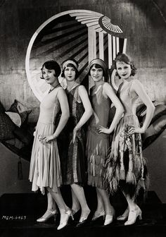
No cultural symbol of the 1920s is more recognizable than the flapper. A young woman with a short “bob” hairstyle, cigarette dangling from her painted lips, dancing to a live jazz band. Flappers romped through the Roaring Twenties, enjoying the new freedoms ushered in by the end of the First World War and the dawn of a new era of prosperity, urbanism and consumerism.
The decade kicked off with passage of the 19th Amendment, which finally gave women the vote. Women also joined the workforce in increasing numbers, participated actively in the nation’s new mass consumer culture, and enjoyed more freedom in their personal lives.
Their wages might not have matched that of their male counterparts, but working women used their purchasing power to join the nation’s new mass consumer culture. Domestic life, especially for urban women, dramatically changed. By 1927, nearly two-thirds of American homes had electricity, and new consumer goods like the washing machine, refrigerator and vacuum cleaner were revolutionizing housework and home life. Women were the major target audience for many of the new products, including household appliances, clothing and cosmetics.
The nature of marriage also started to change. There was more of a sense of companionship between men and women in marriage. Birth control was becoming more widely available, at least for more privileged women, which helped limit family size and allowed women the freedom to explore their sexuality without facing the consequences of unwanted pregnancies.
There was more freedom in women’s personal lives [in the 1920s] in terms of clothing, dancing, the social world and the like.
This freedom had limits, however, and marriage always remained the ultimate goal. Only about 10 percent of women in the 1920s kept their jobs after marriage, most of them working-class women whose family needed their paycheck.
IMMIGRATION QUOTAS
Nativists were concerned that immigrants would diminish America’s political and economic power. They believed immigrants had undesirable physical and social traits. These views were based on eugenics, or the belief that intelligence and strong physical traits were found more frequently in some races than others. Nativists also believed in Social Darwinism, or that only the fittest members of society should be allowed to enter the United States.
In 1917, the U.S. Congress enacted the first widely restrictive immigration law. The uncertainty generated over national security during World War I made it possible for Congress to pass this legislation, and it included several important provisions that paved the way for a later 1924 Immigration Act. The 1917 Act implemented a literacy test that required immigrants over 16 years old to demonstrate basic reading comprehension in any language. It also increased the tax paid by new immigrants upon arrival and allowed immigration officials to exercise more discretion in making decisions over whom to exclude. Finally, the Act excluded from entry anyone born in a geographically defined “Asiatic Barred Zone” except for Japanese and Filipinos. In 1907, the Japanese Government had voluntarily limited Japanese immigration to the United States in the Gentlemen’s Agreement. The Philippines was a U.S. colony, so its citizens were U.S. nationals and could travel freely to the United States. China was not included in the Barred Zone, but the Chinese were already denied immigration visas under the Chinese Exclusion Act.
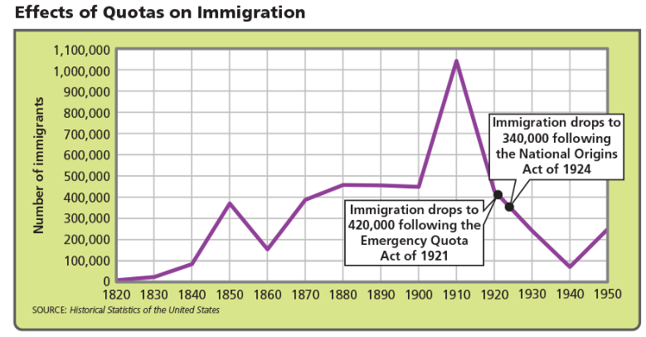
Another set of immigration laws, Emergency Quota Act of 1921 and the National Origins Act, set up a formula to govern immigration. The number of immigrants of a given nationality each year could not exceed 2 percent of the number of people of that nationality living in the United States in 1890. This new act permitted about 65,000 immigrants from England and Ireland every year, but only about 6,000 immigrants from Italy.

