ABOLITIONISM IN THE UNITED STATES - DUE 12/2/19

Overview
- Abolitionism was a social reform effort to abolish slavery in the United States. It started in the mid-eighteenth century and lasted until 1865, when slavery was officially outlawed after the passage of the Thirteenth Amendment to the Constitution.
- The movement evolved from religious roots to become a political effort that at times erupted into violence.
- Though most abolitionists were white, devoutly religious men and women, some of the most powerful and influential members of the movement were African American women and men who escaped from bondage.

Origins of the abolition movement
Opposition to slavery started as a moral and religious movement centered on the belief that everyone was equal in the eyes of God. Not confined to a single church, early antislavery sentiment was common among Mennonites, Quakers, Presbyterians, Baptists, Amish, and other practitioners of Protestant denominations. From its religious roots in the eighteenth century, abolitionist sentiment, or the belief slavery should be completely eradicated, evolved into the formation of antislavery societies in the early nineteenth century. These societies aimed to raise awareness about the moral evils of slavery. The moral character of the abolitionist appeals were a common rhetorical feature of the Second Great Awakening, a bubbling social movement of the first half of the nineteenth century.
The colonization movement, an early effort of the abolition movement, sought to free enslaved people and send them back to Africa. This was viewed by antislavery activists as a compromise with a deeply racist white society that they believed would never accept black equality. The American Colonization Society, founded in 1817, set up a colony on the west coast of Africa in 1822, called Monrovia, in present-day Liberia. By 1860, nearly 12,000 African Americans had returned to Africa. But the colonization project met with hostility from white Southern slaveholders who were adamantly opposed to freeing their slaves. Moreover, some abolitionists opposed the colonization movement, viewing it as unjust to remove African Americans from the land of their birth.

Abolitionism in black and white

The Missouri Compromise of 1820, which allowed Missouri to enter the Union as a slave state, ignited antislavery sentiment in the North. The abolitionist movement, which gathered steam in the years after the compromise, was centered in New England and many prominent leaders of the movement were white, upper-middle-class social reformers and clergy members.
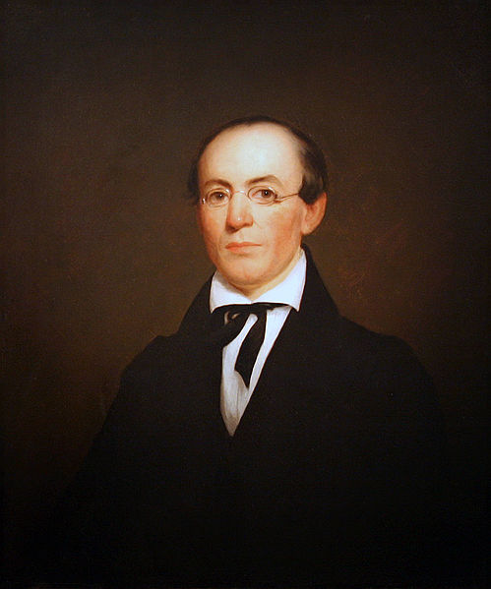
William Lloyd Garrison, a journalist from Massachusetts, was one of the most radical and influential abolitionists. In 1831, he founded the abolitionist newspaper The Liberator, which advocated for the immediate emancipation of all enslaved men and women. In the first issue of The Liberator, Garrison published an open letter, “To the Public,” which called for the “immediate enfranchisement of our slave population." Garrison was also one of the most radical members of the American Anti-Slavery Society, AAS, a national organization established in 1833. The AAS was highly effective at igniting moral outrage over the institution of slavery, but ultimately, the organization was impeded by disagreements between members over the position of women and tactical uses of violence within the antislavery movement.

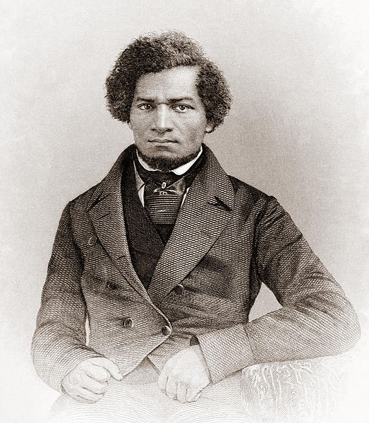
Many Americans reacted negatively to seeing women so active in the public sphere. This propelled the question of a woman’s proper role in society to the forefront of political debate; the Grimké sisters then became instrumental in a related social cause, the early women’s rights movement . Lydia Maria Child, an abolitionist and feminist, observed, “The comparison between women and the colored race is striking . . . both have been kept in subjection by physical force.” Other women who would become prominent in the women’s rights movement, including Elizabeth Cady Stanton, Lucy Stone, and Susan B. Anthony, agreed.
Free northern African Americans, as well as those who had escaped enslavement, played a vital role in the movement by virtue of their firsthand experience of slavery. In 1845, Frederick Douglass—who had escaped slavery himself—published his memoir, Narrative of the Life of Frederick Douglass, an American Slave, one of the most influential memoirs of an enslaved person in history.

Increasing sectional division over slavery
In 1850, Congress passed the Fugitive Slave Act, which legally required Americans to return any African American who had escaped enslavement to his or her owner. It was a major victory for the slaveholding South and directly inspired social reformer and abolition activist Harriet Beecher Stowe to pen the novel Uncle Tom’s Cabin, which quickly became a bestseller and fueled the antislavery cause across the nation. Abolitionism would soon become more radical in response to the political developments and rising sectional tension of the 1850s.

Dred Scott v. Sandford
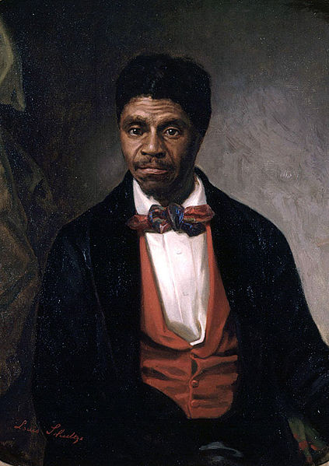
In 1857, the Supreme Court decided the case of Dred Scott v. Sandford. Dred Scott (Figure), born a slave in Virginia in 1795, had been one of the thousands forced to relocate as a result of the massive internal slave trade. His first owner, Peter Blow, sold him to John Emerson, who took Scott and his wife to Missouri, where slavery had been adopted as part of the Missouri Compromise. But in 1820, John Emerson left Scott with his brother John Sanford (misspelled Sandford in court papers) who took Scott to Illinois and then to the Wisconsin territory. Critically, both of those regions were part of the Northwest Territory, where the 1787 Northwest Ordinance had outlawed slavery. When Scott returned to Missouri, he attempted to sue in the state courts for his freedom. He claimed that his residence in a free territory made him a free man. His case made it all the way to the Supreme Court, where it was determined that slaves were property and that Scott was not a free man just because he had been taken to free territory.

The Lincoln-Douglas debates
The turmoil in Kansas, combined with the furor over the Dred Scott decision, provided the background for the 1858 senatorial contest in Illinois between Democratic senator Stephen Douglas and Republican hopeful Abraham Lincoln. Lincoln and Douglas engaged in seven debates throughout Illinois before huge crowds. Newspapers throughout the United States published their speeches. Whereas Douglas already enjoyed national recognition, Lincoln remained largely unknown before the debates.

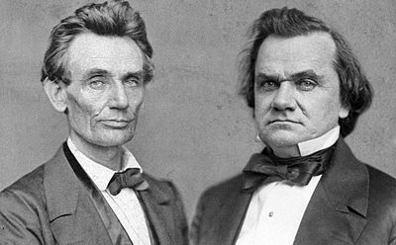
Douglas portrayed the Republican Party as an abolitionist effort. He claimed that by advocating for slavery’s prohibition in the United States, the Republican Party aimed to bring about miscegenation, or race-mixing through sexual relations or marriage. Lincoln, on the other hand, stood firmly on the side of the Union, giving his famous “House Divided” speech, in which he said:
“A house divided against itself cannot stand. I believe this government cannot endure permanently half Slave and half Free. I do not expect the Union to be dissolved—I do not expect the house to fall—but I do expect it will cease to be divided. It will become all one thing, or all the other.”
Furthermore, Lincoln interpreted the Dred Scott decision and the Kansas-Nebraska Act as efforts to nationalize slavery: that is, to make it legal everywhere from New England to the Midwest and beyond. He opposed these efforts.
Although Douglas ultimately won the seat, the debates propelled Lincoln into the national political spotlight. These appearances provided an opportunity for him to raise his profile with both Northerners and Southerners.

Respond to the following questions on a separate sheet of paper (preferably typed).
- What were the most important influences on the abolitionist movement? What were abolitionists trying to achieve? By what methods did they try to achieve their goals?

- In your opinion, who was the most influential abolitionist leader? Why? Justify your response with details from the text and your knowledge of US History

- How were the abolitionist and early women’s movements related?

- What happened to Dred Scott? How did his case increase sectionalism and tensions over slavery?

- Why were the Lincoln-Douglas debates significant? What did Douglas accuse Lincoln of? (Hint: He hoped this accusation would make Lincoln lose support in the South). What was the impact of the debates on Lincoln’s political career?

