Frederick Douglass vs. Nat Turner
Document A: Frederick Douglass, What to the Slave is the 4th of July? (1852)
Background
Frederick Douglass was an escaped slave who dedicated his life to ending slavery. He spoke to large crowds in the North about the evils and injustices of slavery. He was an intellectual who used speeches and his newspaper, the North Star, to argue in favor of abolition. Below is an excerpt from a speech that Douglass gave on the 4th of July 1852 to the Rochester Ladies’ Anti-Slavery Society.
Primary Source
Citizens, your fathers [won you independence] and today you reap the fruits of their successes. The freedom gained is yours; and you, therefore, may properly celebrate this anniversary. The 4th of July is the first great fact in your nation’s history…
But… I say it with a sad sense of the disparity between us. I am not included within the pale of glorious anniversary! Your high independence only reveals the distance between us. The blessings in which you, this day, rejoice, are not enjoyed in common. The rich inheritance of justice, liberty, prosperity and independence, bequeathed by your fathers, is shared by you, not by me...You may rejoice, I must mourn.
Fellow-citizens, above your national, tumultuous joy, I hear the mournful wail of millions!
What, to the American slave, is your 4th of July? I answer; a day that reveals to him, more than all other days in the year, the gross injustice and cruelty to which he is the constant victim.
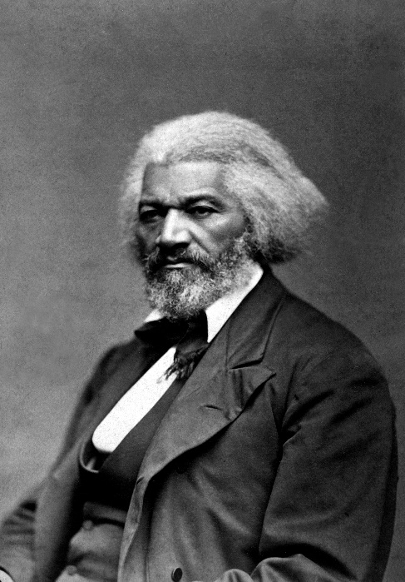
To him, your celebration is a sham; your boasted liberty, your national greatness, sounds of rejoicing are empty and heartless; your shouts of liberty and equality, your sermons and thanksgivings are mere fraud, deception, and hypocrisy—a thin veil to cover up crimes which would disgrace any nation. There is not a nation on the earth guilty of practices more shocking and bloody than are the people of the United States, at this very hour.
Now, take the Constitution according to its plain reading… interpreted as it ought to be interpreted, the Constitution is a glorious liberty document… it will be found to contain principles and purposes, entirely hostile to the existence of slavery…

Document B: Nat Turner’s Slave Rebellion
Nathanial “Nat” Turner (1800-1831) was a black American slave who led the only effective, sustained slave rebellion (August 1831) in U.S. history. He was born on the Virginia plantation of Benjamin Turner, who allowed him to be instructed in reading, writing, and religion. Sold three times in his childhood and hired out to John Travis (1820s), he became a fiery preacher and leader of African-American slaves on Benjamin Turner’s plantation and in his Southampton County neighborhood, claiming that he was chosen by God to lead them from bondage.

Believing in signs and hearing divine voices, Turner was convinced by an eclipse of the Sun (1831) that the time to rise up had come. He enlisted the help of four other slaves in the area. An insurrection was planned, aborted, and rescheduled for August 21,1831, when he and six other slaves killed the Travis family, managed to secure arms and horses, and enlisted about 75 other slaves in a disorganized insurrection that resulted in the murder of 51 white people.

Afterwards, Turner hid successfully for six weeks until his discovery, conviction, and hanging at Jerusalem, Virginia, along with 16 of his followers.

Turner’s Rebellion showed that slaves had agency and were willing to use violence to achieve freedom. Slaves were capable of fighting for their freedom.

However, Turner’s actions also struck fear in the hearts of southern slaveowners who responded by making harsher laws pertaining to the treatment of slaves. After Turner’s Rebellion, slaves were prohibited from receiving an education, assembling in large groups, or even traveling on the plantation. Overall, Turner’s violent rebellion further entrenched the southern pro-slavery argument. 56 blacks were accused of participating in the uprising and were executed. 200 others were beaten by angry white mobs.

Name: ________________________________________ Date: _______
US History Douglass vs. Turner

Directions: Answer all questions in complete sentences. Each response should be at least 5 sentences. Your responses must be typed (double-spaced, 12-point font)

Use Document A to answer questions 1 through 2

- According to Douglass, what to the slave is the Fourth of July? Does he feel included in the 1852 Fourth of July celebration? What criticisms about American society does he make?

- What document provides Douglass with hope? Why does he find hope in this document?

Use Document B to answer questions 3 through 4
- How did Nat Turner contribute to the abolition movement?
- What were the unintended results of Turner’s Rebellion? Why did these consequences occur?

Use both Documents A and B to answer question 5

- Compare and contrast the actions taken by Frederick Douglass and Nat Turner and assess to what extent each individual was successful in trying to achieve abolition.

