THE “SPOILS SYSTEM”

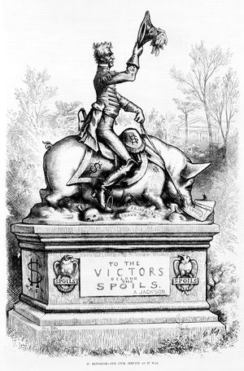
When Andrew Jackson became President in 1828, he fired an enormous number of government employees. He replaced them with members of the Democratic Party and friends that had helped him during his campaign. In many instances Jackson was not concerned with whether or not the people he hired were qualified for the job. Rather, he felt that he owed many people for helping him get elected and claimed that employee turnover and “rotation in office” in the government was a good thing for democracy because it allowed new voices to be heard. To combat the patronage and this “spoils system” created by Jackson, the United States now uses civil service exams to fill many jobs in the government. These exams determine whether or not a person is qualified for the job they’re applying for.
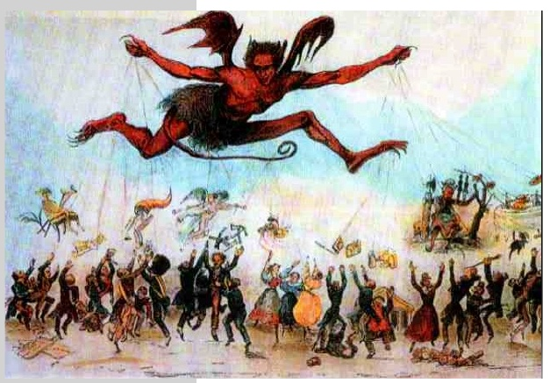

THE NULLIFICATION CRISIS
January 1830

South Carolina threatens to nullify, or reject, the tariff
1828

Congress passes a tariff on imported goods. It benefits the industrial North, but hurts the South, where many manufactured goods must be imported

Southerners label the tariff the “Tariff of Abomination”

November 1832

South Carolina declares the Tariff of 1832 unconstitutional and null & void

They threaten to secede from the Union if the federal government does not respect the nullification
July 14, 1832

Congress passes a new tariff that imposes less severe taxes

South Carolina is still displeased

March 2, 1833

Congress passes the “Compromise Tariff”

South Carolina views this tariff as acceptable and cancels its nullification act
1833

Congress passes the “Force Bill,” expanding federal power

President Jackson threatens to send 50,000 troops to South Carolina to enforce federal law

THE BANK WAR
The original Bank of the United States was chartered in 1791 at the urging of Secretary of the Treasury Alexander Hamilton. Opposition to it was one of the founding tenets of the Jeffersonian Democratic-Republican party. That party allowed the Bank to expire when its twenty-year charter ran out in 1811. But the government's financial misadventures in the War of 1812 forced reconsideration. In 1816, Congress chartered the Second Bank of the United States, again for twenty years.
Corrupt management ruled the Second Bank until 1819. Calls arose to remove the bank. By 1828, however, when Jackson was first elected, many people had stopped caring about the Bank.
Startling his own supporters, Jackson attacked the Bank in his very first message to Congress in 1829. He was convinced that the Bank was unconstitutional—as Jefferson and his followers had long argued. Jackson insisted that the Bank favored the interests of northern businessmen and the rich. When Congress voted to extend the National Bank’s charter, Jackson, claiming to do so in the name of farmers, laborers, and the “humble members of society” vetoed it.

THE INDIAN REMOVAL ACT
The Indian Removal Act, passed by President Jackson, forcibly removed Native Americans from the southern United States and relocated them to territories further west. Most natives were forced to move to modern day Oklahoma. The stated goal of the act was to peacefully negotiate treaties that gave southern states ownership over Native American lands in exchange for land in Oklahoma. President Jackson even stated in 1830:
“the policy of [the U.S. Government] toward the red man is generous. He is unwilling to submit to the laws of the States and mingle with their population. To save him from this alternative, or annihilation, the [U.S. Government] kindly offers him a new home…”

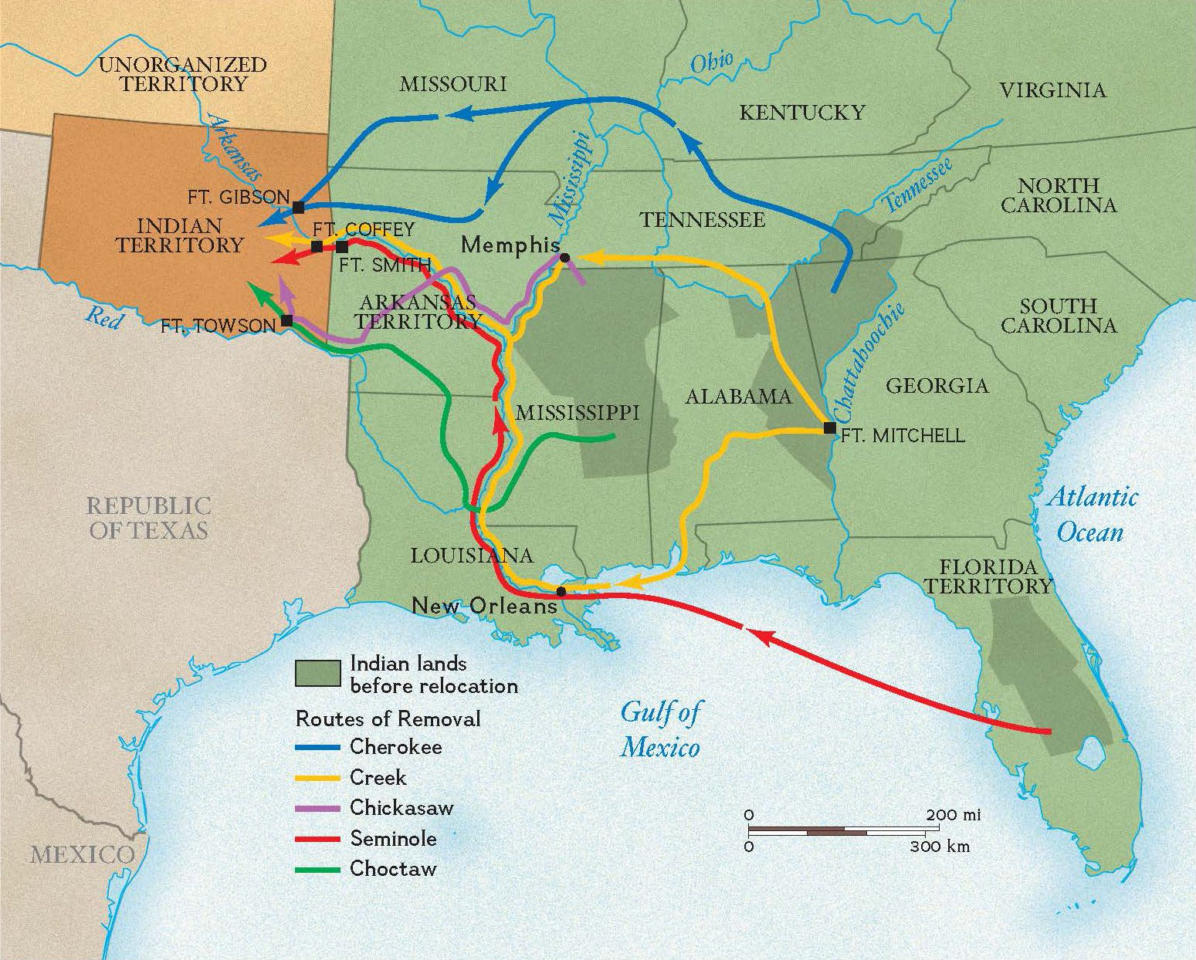
Image by National Geographic Society Flip Over
The Cherokee nation refused to leave their lands. In 1838, U.S. soldiers forced 16,000 Cherokees to walk a path that’s now known as the Trail of Tears. At least 4,000 Cherokees died of disease, hunger, and exposure to the elements.

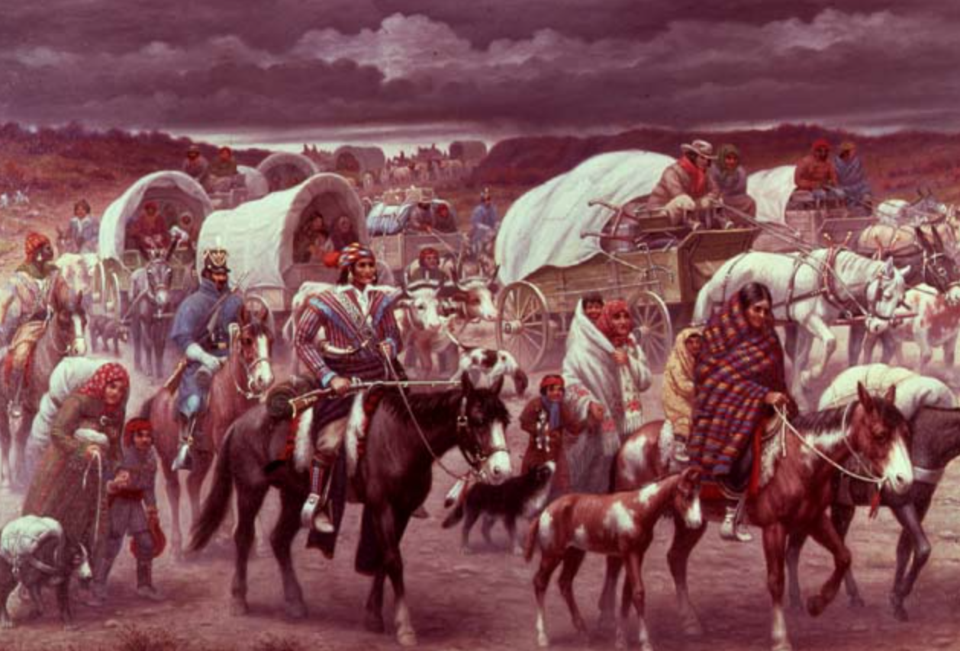
Oil Painting by Robert Lindneux, 1942

