The Missouri Compromise and the Compromise of 1850
Answer the questions that follow on your own paper using complete sentences (you may type)
The questions are under the section they apply to.

The Missouri Compromise
Slavery had come to America in 1619. It existed through the American Revolution, even after Thomas Jefferson penned his famous lines in the Declaration of Independence, "All men are created equal. They are endowed by their creator with certain unalienable rights. That among these are life, liberty, and the pursuit of happiness." Obviously, slaves were not part of this equation. When it came time to write the Constitution, the word "slavery" was never used. Instead, the framers chose to use the term "other people." These other people were counted as 3/5 of a person for the purposes of representation in Congress according to the 3/5 Compromise. This compromise kept slavery in the United States intact. The founders also decided not to do anything about the issue of slavery for twenty years. Someone else would have to deal with it.
In 1820 with the admission of Missouri to the Union, the issue of slavery came up again. There was already a great deal of tension between the North and the South. The South was highly agricultural. It wanted to keep slavery as a way of life on their plantations. The North, which was far more industrial, saw this "peculiar institution" as unnecessary and increasingly morally wrong. One way the government tried to limit the tension was by keeping the number of slave and free states equal. So, in 1820, when Missouri met the requirements for statehood and applied for admission to the Union as a slave state, there was a problem. The balance of free and slave states would be destroyed.
The Missouri Compromise seemed to solve the problem by admitting Missouri as a slave state and Maine as a free state, keeping the number of free and slave states equal. It also divided the rest of the Louisiana Purchase into slave and free territory.
1. Did the writers of the Constitution solve the slavery issue? What was the name of the compromise that dealt with slavery that was written into the Constitution?

2. Why was there already tension between the Northern United States and the Southern United States in 1820?

3. How did the Missouri Compromise solve the problem of the balance between free and slave states?
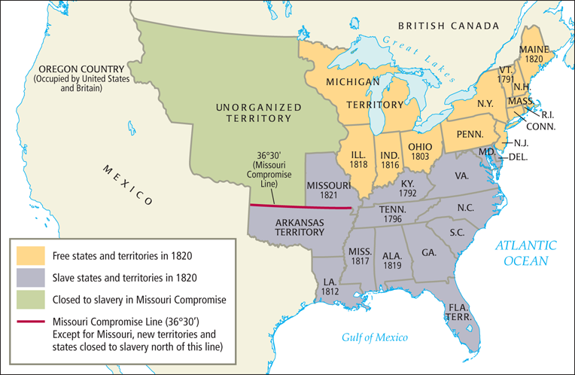

4. What year was Maine admitted into the United States? Was it a free state or a slave state?

5. What year was Missouri admitted into the United States? Was it a free state or a slave state?

Excerpt from Missouri Compromise (1820)
And be it further enacted. That in all that territory ceded by France to the United States, under the name of Louisiana, which lies north of thirty-six degrees and thirty minutes north latitude, slavery shall be, and is hereby, forever prohibited: Provided always, That any person escaping from slavery...may be lawfully reclaimed and conveyed back to the person (slave owner)...

6. According to the text above, what happened to runaway slaves under the Missouri Compromise?

The Compromise of 1850
By 1850, the United States had acquired more land in the west as a result of the Mexican American War. Because of this new vast territory, the issue of slavery became a major point of contention between the North and South again. Should the new territories allow slavery? Should the inhabitants of the new territories get to decide?
California also contributed to the problem. After the gold rush of 1849 resulted in California’s rapid economic growth, it asked to join the United States as a free state. Should this be allowed? If California entered as a free state, it would throw off the balance that had been created by the Missouri Compromise.

7. Why was admitting California as a free state a potential problem?

Henry Clay, the now 70-year-old U.S. Senator helped to develop a new compromise. According to the Compromise of 1850, the slave trade in Washington D.C. would be abolished and California would be admitted as a free state. To please the slave states who would have objected to the imbalance created by adding another free state, the Compromise of 1850 included a new law: The Fugitive Slave Act.

8. What happened to California under the Compromise of 1850?

9. Why was the Fugitive Slave Act included in the compromise?

The Fugitive Slave Act made people in free states return runaway slaves. Law enforcement officers were obligated to arrest alleged runaway slaves. Any officer who caught a runaway slave received a bonus in their paycheck. Additionally, anyone who aided a runaway slave by providing food or shelter could be imprisoned for six months or fined $1,000. Suspected slaves were not given a trial. Many free blacks who were not runaways were sent into slavery because they had no right to defend themselves in court.

10. What were 2 effects of the Fugitive Slave Act?
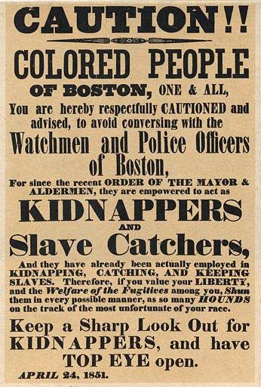
11. What warning was being issued to the people of Boston in the above poster? Why?
Passage of the Fugitive Slave Act made abolitionists (people who wanted to end slavery) more resolved to put an end to slavery. The Underground Railroad became more active, reaching its peak between 1850 and 1860. The act also brought the subject of slavery before the nation. Many who had previously been ambivalent about slavery now took a definitive stance against the institution.
12. What was one positive effect of the Fugitive Slave Act?
The Compromise of 1850 accomplished what it set out to do -- it kept the nation united -- but the solution was only temporary. Over the following decade the country's citizens became further divided over the issue of slavery. The rift would continue to grow until the nation itself divided.
13. What did the Compromise of 1850 accomplish?
14. What issue would continue to divide the nation over the next decade?
15. Overall, why did the expansion of the U.S. lead to more sectionalism between the North and South?

