LIFE IN THE SOUTH DURING RECONSTRUCTION FOR A FREEDMAN

After the Civil War, the United States had to figure out how to get back together. Three Amendments were passed, known as the Reconstruction Amendments. The 13th Amendment abolished slavery, the 14th gave freed blacks the rights enjoyed by U.S. citizens, and the 15th gave male African Americans the right to vote.

The south, however, did not easily accept the equality of blacks. Many southern states passed laws and developed systems to continue to limit the rights of African Americans, even after the end of the Civil War and the abolition of slavery.

Southern states implemented sharecropping systems, which basically kept freed blacks enslaved. They used literacy tests and poll taxes to prevent African Americans from voting. Many southern states even passed Black Codes and Jim Crow laws to limit what African Americans, supposedly free people, could do. Many ex-Confederates joined the Ku Klux Klan, an organization that terrorized blacks in the south.

Read and analyze the following documents showing how the south continued to limit the rights of African Americans during Reconstruction.

Primary Source  Document Analysis | Sharecropper Contract

Thomas J. Ross agrees to employ the Freedman who sign below to plant and raise a crop on his Rosstown Plantation...On the following rules and regulations:

Superintendent Ross agrees to furnish: the land to cultivate, a sufficient number of mules & horses [and feed for said animals], house for said crop, and all necessary farming tools to carry on the planting...and Ross will give to said Freedman: one half of all the cotton, corn and wheat that is raised on said place for the year 1866, after all the necessary expenses are deducted out that accrues on said crop…

Outside of the Freedmen's labor in harvesting, carrying to market and selling the same, the said Freedmen will plant, cultivate, and raise in good faith, a cotton, corn and oat crop under the management of Superintendent Ross….

And said Freedmen agrees to furnish ourselves & families in provisions, clothing, medicine, and medical bills and all and every other kind of expenses that we may incur on said plantation for the year 1866 free of charge to said Ross. Should Ross furnish us any of the above supplies or any kinds of expenses, during said year, are to settle and pay him out of the net proceeds of our part of the crop the retail price of the county at time of sale or any price we may agree upon….The said Ross shall keep a regular book account . . . to be adjusted and settled at the end of the year . . .

We furthermore bind ourselves to and with said Ross that we will do good work and labor ten hours a day on an average, winter and summer. The time to run the time we commence to the time we quit...We further agree that we will lose all lost time, or pay at the rate of one dollar per day, rainy days excepted. In sickness and women lying in childbed are to lose the time and account for it to the other hands out of his or her part of the crop at the same rates that she or they may receive per year.

We furthermore bind ourselves that we will obey the orders of Ross in all things in carrying out and managing the crop for the year and further bind ourselves that we said Freedmen will keep up the fences around the enclosures, and lots especially and if any rails be missing by burning or otherwise destroyed by said Freedmen, we will pay for them or otherwise reconstruct the fence anew at our expense . . .

All is responsible for all farming tools that is on hand or may be placed in care of said Freedmen for the year 1866 to said Ross and are also responsible to said Ross if we carelessly, maliciously maltreat any of his stock for said year to said Ross for damages to be assessed out of our wages for said year, all of which is understood by us Freedmen in the foregoing contract, or agreement.... It is further agreed by us whose names appear below that we will keep a sufficiency of firewood hauled up at all times and make fires in the room of Ross, when desired, attend to all stock properly, under direction of said Ross…
Freedmen: former slaves now working as sharecroppers
Cultivate: to farm or grow
Accrues: arise from
Incur: meet with
Commence: begin
Enclosures: area that is sealed off - in this case, each sharecropper had their own enclosure

LITERACY TESTS POLITICAL CARTOON

The following is a political cartoon from Harper’s Weekly which was published in January 1879. The caption reads: “The color line still exists - in this case”. An early image of Uncle Sam is seen writing the following words on the wall: “Eddikashun qualifukashun. The Black man orter be eddikated afore he kin vote with US Wites, signed Mr. Solid South.” [Translation: Education Qualification. The Black man ought to be educated before he can vote with US whites, signed Mr. Solid South]

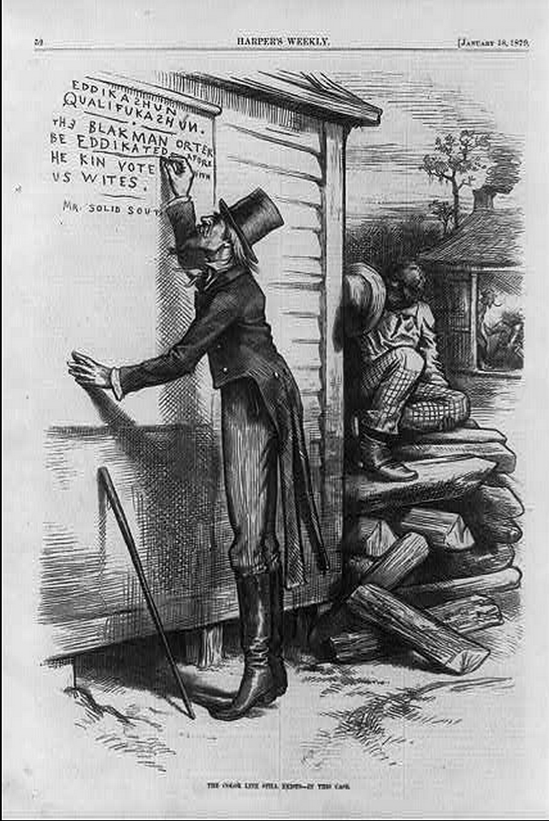

Observations | Inferences
I notice or I see… | Because I see this, I think…

JIM CROW LAWS

Starting in the Reconstruction Era (late 1860s), and lasting until as late as the 1960s, many states across the nation passed and enforced a separate set of laws for African Americans. Known as Jim Crow laws or Black Codes, most of these laws applied to anyone with more than “⅛ negro blood”. Below is an excerpt of such laws from various states across the nation. It is important to remember that these are just a sample of the laws that were in existence during this time period.
Alabama:

- No person or corporation shall require any white female nurse to nurse wards or rooms in hospitals, either public or private, in which negro men are placed.

- All passenger stations in this state operated by any motor transportation company shall have separate waiting rooms or space and separate ticket windows for the white and colored races.

- It shall be unlawful to conduct a restaurant or other place for the serving of food in the city, at which white and colored people are served in the same room, unless such white and colored persons are effectually separated by a solid partition extending from the floor upward to a distance of seven feet or higher

- It shall be unlawful for a negro and a white person to play together or in the company with each other in any game of cards or dice, dominoes, or checkers.

Nebraska:

- Marriages are void when one party is a white person and the other is possessed of one-eighth or more negro, Japanese, or Chinese blood.

Wyoming:

- When there are 15 or more colored children within any school district, the board of directors thereof, with the approval of the county superintendent of schools, may provide for a separate school for instruction of colored children.

North Carolina:

- Books shall not be interchangeable between the white and colored schools, but shall continue to be used by the race first using them.

- The state librarian is directed to fit up and maintain a separate place for the use of the colored people who may come to the library for the purpose of reading books or periodicals.

Georgia:

- It shall be unlawful for any amateur white baseball team to play baseball on any vacant lot or baseball diamond within two blocks of a playground devoted to the Negro race, and it shall be unlawful for any amateur colored baseball team to play baseball in any vacant lot or baseball diamond within two blocks of any playground devoted to the white race.

The Ku Klux Klan
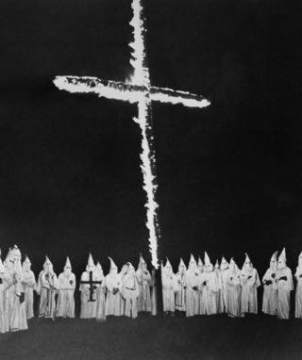
Reconstruction politics was a catalyst for widespread racism and hatred that freed people experienced throughout the South. The Ku Klux Klan, founded by a Confederate general in 1866, became known as the "invisible empire of the South" in which members represented the ghosts of the Confederate dead returning to terrorize African Americans and Republicans. Although it was a covert organization, the Klan’s displays of violence and intolerance were anything but discreet. Many murders and beatings were never reported due to fear of reprisal from the Klan. This document is an example of the type of threats for which the KKK became known. In this case, the target was Davie Jeems, a black Republican recently elected sheriff in Lincoln County, Georgia.

Notice
To Jeems, Davie. you. must. be, a good boy. and. Quit. hunting on Sunday and shooting your gun in the night. you keep people from sleeping. I live in a big rock above the Ford of the Creek. I went from Lincoln County County [sic] during the War I was Killed at Manassus in 1861. I am here now as a Locust in the day Time and. at night I am a Ku Klux sent here to look after you and all the rest of the radicals and make you know your place. I have got my eye on you every day, I am at the Ford of the creek every evening From Sundown till dark I want to meet you there next Saturday tell platt Madison we have, a Box. For him and you. We nail all, radicals up in Boxes and send them away to KKK - there is. 200 000 ded men retured to this country to make you and all the rest of the radicals good Democrats and vote right with the white people.

Name: ___________________________________________ Date: _________
US History Reconstruction in the South

Analysis Questions: Sharecropping Contract

- Keeping in mind that this contract was written immediately after the slaves were freed - and keeping in mind that slaves had little to no literacy or education, who do you think often wrote sharecropping contracts?
  - How does this bias the system of sharecropping? Who has the advantage, newly freed slaves or plantation owners? Why?

________________________________________________________________________________________________________________________________________________________________________________________________________________________________________________________________________________________________________________________________________________________________________________________________________________________________________________________________________________________________________________________________________________
- How does the contract limit the freedom of the laborers?

____________________________________________________________________________________________________________________________________________________________________________________________________________________________________________________________________________________________________________________________________________________________________________________________________________
- What does the plantation owner provide?

________________________________________________________________________________________________________________________________________________________________________________________________________________________________________________________________________
- Sharecropping freedmen often incurred debt to the former plantation owners by borrowing credit for household goods, medical expenses, etc. They were charged large interest rates and often ended up paying back much more than they borrowed. How does this system keep freedmen in debt? Do you think this is almost a type of pseudo-slavery? Why or why not?

____________________________________________________________________________________________________________________________________________________________________________________________________________________________________________________________________________________________________________________________________________________________________________________________________________________________________________________________________________________________________________________________________________________________________________________________________________________________________________________________________________________
Analysis Questions: Literacy Tests Political Cartoon

- What topic is the political cartoon addressing? What must a black man do before he can vote in the south?

________________________________________________________________________________________________________________________________________________________________________________________________________________________________________________________________________
- Construct a claim/argument about Reconstruction (using your inference) and provide evidence (using your observation) to support the claim.

____________________________________________________________________________________________________________________________________________________________________________________________________________________________________________________________________________________________________________________________________________________________________________________________________________
- What point do you think the cartoonist was trying to make about literacy tests and their impact on disenfranchisement of African Americans? How does the cartoonist use irony to make his point?

________________________________________________________________________________________________________________________________________________________________________________________________________________________________________________________________________________________________________________________________________________________________________________________________________________________________________________________________________________________________________________________________________________
Analysis Questions: Jim Crow Laws

- What, if any, repeating themes or patterns do you see in these laws?

____________________________________________________________________________________________________________________________________________________________________________________________________________________________________________________________________________________________________________________________________________________________________________________________________________
- How do you think these laws impacted or shaped the interactions between newly freed blacks and whites in American society during the Reconstruction Era?

____________________________________________________________________________________________________________________________________________________________________________________________________________________________________________________________________________________________________________________________________________________________________________________________________________
- What long term impact do you think these laws would or did have on shaping American society?

________________________________________________________________________________________________________________________________________________________________________________________________________________________________________________________________________________________________________________________________________________________________________________________________________________________________________________________________________________________________________________________________________________
- How are these laws similar or different to the restrictions placed on African Americans when they were enslaved?

________________________________________________________________________________________________________________________________________________________________________________________________________________________________________________________________________________________________________________________________________________________________________________________________________________________________________________________________________________________________________________________________________________
Analysis Questions: The Ku Klux Klan

- What was the purpose of the notice posted by a member of the KKK? Why would this notice be posted publicly?

___________________________________________________________________________________________________________________________________________________________________________________________________________________________________________________________________________________________________________________________________________________________________________
- How does the notice show the KKK’s reliance on the supernatural? Why do you think the KKK referred to the supernatural in the first place?

____________________________________________________________________________________________________________________________________________________________________________________________________________________________________________________________________________________________________________________________________________________________________________________________________________________________________________________________________________________________________
- To what extent does the notice show the anger of some white Southerners to the policies of the Radical Republicans in Congress? How would Republicans respond to this notice?

_____________________________________________________________________________________________________________________________________________________________________________________________________________________________________________________________________________________________________________________________________________________________________________________________________________________________________________________________________________________________________________________________________________________________________________________________________________________________

Final Challenge: Bring it all together

- Overall, why did the southern states implement sharecropping, Jim Crow Laws, literacy tests, Black Codes, and the Ku Klux Klan during Reconstruction?

_____________________________________________________________________________________________________________________________________________________________________________________________________________________________________________________________________________________________________________________________________________________________________________________________________________________________________________________________________________________________________________________________________________________________________________________________________________________________

