Station 1: Shortages

A shortage exists when an excess demand for a product persists for a significant period of time.
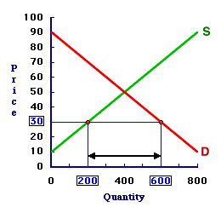
In the graph shown, the supply and demand are not at equilibrium. The demand is higher than can be met by the supply. Usually, firms raise prices and increase production to bring the market back to the equilibrium price. However, if a firm does not increase supply or raise prices quickly enough, it may delay the return to market equilibrium. This can cause issues. Sellers may put limits on the quantity each customer is allowed to purchase or people may have to wait in line for hours to purchase basic needs and wants. Some people may not be able to purchase certain things at all.
Consider an example: Thanksgiving is next week and companies failed to provide a substantial number of turkeys. The demand is higher than the supply. However, companies don’t have enough time to supply enough turkeys to meet the demand. Therefore, there is a shortage of turkeys.

Station 2: Surpluses
A surplus exists when an excess supply persists for a significant period of time
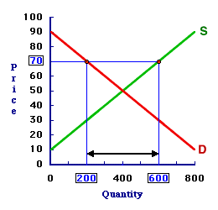
In the graph shown, the supply and demand are not at equilibrium. The amount of the product supplied is higher than the demand for the product. Usually, firms cut prices and halt supplies to bring the market back to the equilibrium price. However, if firms do not cut prices it can result in an excess supply, or a surplus. This can cause issues. Sellers will grow frustrated that their products are not selling. Perishable products, like fresh produce, can go bad on store shelves if it is not sold quickly enough.

Station 3: Price Ceilings

A price ceiling is a government imposed limit on the highest price firms can charge in a market. The goal is to make goods more affordable for consumers.

In New York State, milk prices cannot exceed a price that is considered to be “unconscionably excessive.” Sellers are prohibited from charging more than $4.37 per gallon of milk. As long as the equilibrium price for the milk market is below $4.37, the price ceiling is not binding – it has no effect on the market. If, however, the price ceiling were to be set below the equilibrium price, meaning firms were not allowed to sell milk at the equilibrium price, the ceiling would be considered binding.
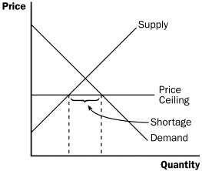
A binding price ceiling causes issues. It can create a shortage where, because the good is being sold below the equilibrium price, the demand for the product outweighs the supply. Therefore, many consumers will not be able to buy the product at all.

Station 4: Price Floors

A price floor is a government imposed limit on the lowest price firms can charge in the market. The goal is to help sellers who might otherwise struggle to stay in business.

Price floors exist in many forms in the United States. In agriculture, the government sets a price floor to make the incomes of farmers who supply crops higher than they would be without the price floor. When a price floor is set above the equilibrium price, meaning sellers must charge more than they normally would in the market, it is considered binding. A binding price floor creates a surplus because the higher price causes the demand for the good to decrease below the equilibrium price. Price floors increase costs for consumers.
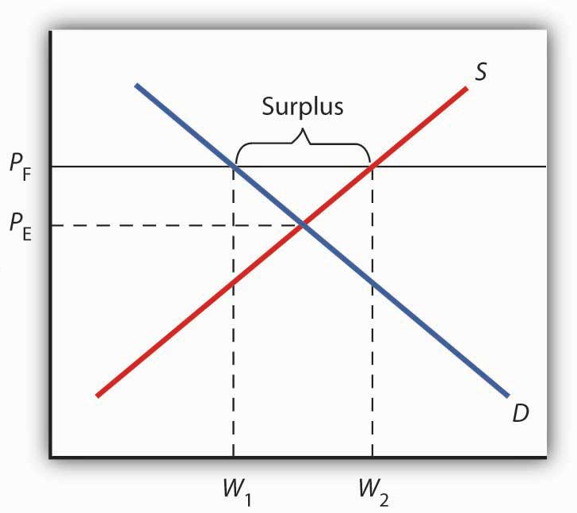
Since the Great Depression, the United States government has been involved in the agriculture business. There are price floors on certain crops. To deal with crop surpluses, the government purchases some of the supply and either stores it, destroys it, or donates it to hunger organizations.

Station 5: Sticky Prices

A sticky price is a price that moves to its equilibrium value very slowly.

When a price is sticky, it moves to its equilibrium price very slowly. It can take weeks, months, or even longer for the market to reach equilibrium. During this time, if the price is below its equilibrium value, there will be a shortage. If the price is above its equilibrium value, there will be a surplus.

When Star Wars: The Force Awakens was released in 2015, advance ticket sales caused websites like Fandango and Regal Movies to crash. The demand for the movie was astronomically high. People were unable to purchase tickets for weeks because of a shortage in movie tickets. However, despite the increased demand, theaters did not raise ticket prices, even though they could have made a larger profit and eliminated the shortage. The price for movie tickets is sticky because customers would become upset if they had to pay a different price depending on which movie they were seeing.

Eventually, the market returned to equilibrium as demand for movie tickets moved back towards its equilibrium value. However, it took some time. Therefore, the movie tickets in this situation had a sticky price.

Name: _______________________________ Date: _______
Economics Role of Prices Stations
Station 1: Shortages
- What is a shortage?

- What types of issues are caused by shortages?

- What is the equilibrium price (in dollars) in the graph shown?

- In order to achieve the equilibrium price in the graph shown, firms would have to provide how many more of the product and increase the price to what?

- Consider the given example concerning Thanksgiving turkeys. What types of choices will people have to make because of the turkey shortage?

Name: _______________________________ Date: _______
Economics Role of Prices Stations
Station 2: Surpluses

- What is a surplus?

- What types of issues are caused by surpluses?

- What is the equilibrium price (in dollars) in the graph shown?

- In order to achieve equilibrium price in the graph shown, firms would have to cut supplies to how much and reduce the price of the product to what?

- Who benefits from a surplus? In what ways can they benefit?

Name: _______________________________ Date: _______
Economics Role of Prices Stations
Station 3: Price Ceilings
- What is a price ceiling? Who sets a price ceiling and why?

- When is a price ceiling considered non-binding? When is a price ceiling considered binding?

- What happens when there is a binding price ceiling?

- Why do firms fail to supply enough product to meet demand when there is a price ceiling?

- In some major cities, the government places a price ceiling on the cost of rent. The intentions may be good, but the effects are usually negative. What specific issues can you foresee a price ceiling on rent causing and why?

Name: _______________________________ Date: _______
Economics Role of Prices Stations
Station 4: Price Floors
- What is a price floor? Who sets a price floor and why?

- When is a price floor considered non-binding? When is a price floor considered binding?

- What happens when there is a binding price floor?

- What are some issues created by price floors? Why does a price floor create these issues?

- The minimum wage is a price floor. What happens to the supply and demand for labor if the price floor is too high? If the minimum wage price floor is set at a point that is binding, what will happen?

Name: _______________________________ Date: _______
Economics Role of Prices Stations
Station 5: Sticky Prices
- What is a sticky price?

- What happens if a sticky price is below its equilibrium value? What if it is above its equilibrium value?

- What is one reason for sticky prices, according to the reading?

- Think of another factor that could result in a sticky price for a particular product.

- Are sticky prices good, bad, or neither? Why?

