Weekly Assignment #1

Document A: Excerpt from The Interesting Narrative of the Life of Olaudah Equiano, Written by himself, 1791

Background

Olaudah Equiano was captured in his home country of Benin in Africa by Africans who sold him to European slave traders. He was taken to the coast and boarded on a slave ship to the New World. That slave ship brought him to North America via the Middle Passage. He eventually purchased his freedom and wrote an autobiography. Below is an excerpt from that autobiography. This is his personal account of what happened to him as he traveled on the slave ship from Africa to the New World. It was published in 1791.

Primary Source

The first object I saw when I arrived on the coast was the sea, a slave ship, which was then riding at anchor, and waiting for its cargo. These filled me with astonishment, which was soon converted into terror, when I was carried on board. I was immediately handled, and tossed up to see if I were sound [healthy], by some of the crew; and I was now persuaded that I had gotten into a world of bad spirits, and that they were going to kill me. . . When I looked round the ship I saw a multitude of black people of every description chained together, every one of them expressing dejection and sorrow, I no longer doubted of my fate; and overpowered with horror and anguish, I fell motionless on the deck and fainted.
When I recovered a little, I found some black people about me, who I believe were some of those who had brought me on board, and had been receiving their pay; they talked to me in order to cheer me… I asked them if we were not to be eaten by those white men with horrible looks, red faces, and long hair.
I was soon put down under the decks, and there I received such a [smell] in my nostrils as I had never experienced in my life… I became so sick and low that I was not able to eat, nor had I the least desire to taste anything. I now wished for death… two of the white men offered me [food] and, on my refusing to eat, one of them held by the hands and tied my feet, while the other flogged [whipped] me severely. I had never experienced anything of this kind before… I would have jumped over the side [of the ship] but the crew watched us very closely…
I inquired of [asked] these [the crew] what was to be done with us. They told me we were to be carried to these white peoples’ country to work for them. I then was a little revived, and thought if it were no worse than working, my situation was not so desperate. But still I feared that I should be put to death, the white people looked and acted in so savage a manner. I have never seen among my people such instances of brutal cruelty, and this not only shown towards us blacks, but also to some of the whites themselves.
One day, when we had a smooth sea and moderate wind, two of my wearied countrymen who were chained together (I was near them at the time), preferring death to such a life of misery, somehow made through the nettings and jumped into the sea. Immediately another quite dejected fellow, who on account of his illness was suffered to be out of irons, followed their example. I believe many more would very soon have done the same if they had not been prevented by the ship's crew, who were instantly alarmed. Those of us that were the most active were in a moment put down under the deck, and there was such a noise and confusion among the people of the ship as I never heard before to stop her and get the boat out to go after the slaves. However, two of the wretches were drowned, but they got the other and afterwards flogged him unmercifully for thus attempting to prefer death to slavery.
Document B: Slave ship on the Middle Passage
Background
The image below is a drawing of a slave ship that would have travelled the Middle Passage from the west coast of Africa to the New World. It depicts two levels of the hold below deck where crews usually stored supplies and cargo. On the Middle Passage, slaves were considered and treated like cargo.
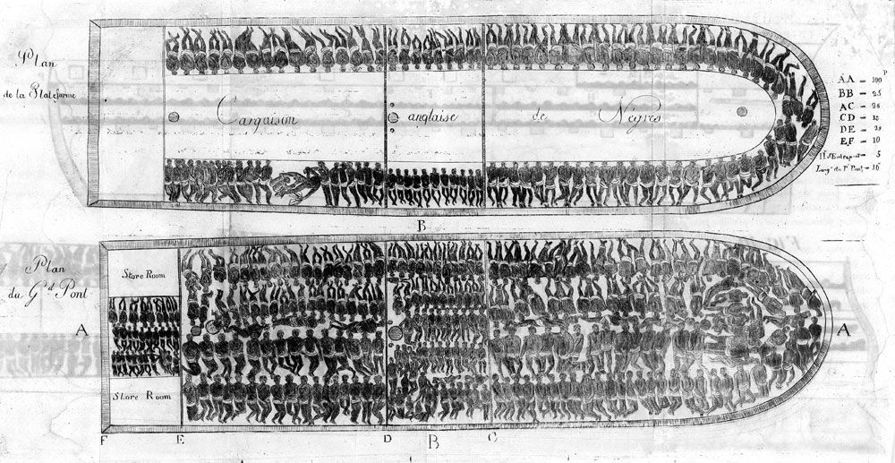
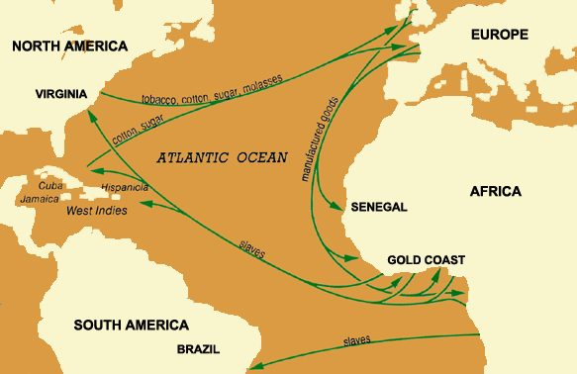
Name: ____________________________________ Date: _________
US History Weekly #1

Directions: Answer all three questions in complete sentences. Each response should be at least 5 sentences. Your responses must be typed (double-spaced, 12-point font)

Answer questions 1 and 2 according to Document A only

- Describe Equiano’s experience on the slave ship to the New World. What did he see? What did he smell? How was he treated?

- Why do you think Equiano was forced to eat, even when he didn’t want to? Why did slaves attempt to jump overboard? Why did the crew try so hard to stop them?

- How reliable is Document A for understanding the Middle Passage and how slaves were treated during the journey to the New World? Think about who Equiano was and what he saw.

Answer question 3 according to Document A and Document B

- Explain the Triangular Trade system that dominated the Atlantic Ocean during the seventeenth and eighteenth centuries. What did the system look like? What types of goods were traded? Where did they go? Why did landowners in the New World want slaves?

