Weekly #3 – Due 9/27/18

Document A: Proclamation of 1763, King George III of England

Background

After the French and Indian War, France essentially lost claim to all its land in the New World. This meant that British North America now extended well past the territory that made up the 13 British colonies. However, after a Native American chief, Pontiac, led a revolt against English settlers, King George III of England passed a proclamation prohibiting the colonists in America from moving west of the Appalachian Mountains.
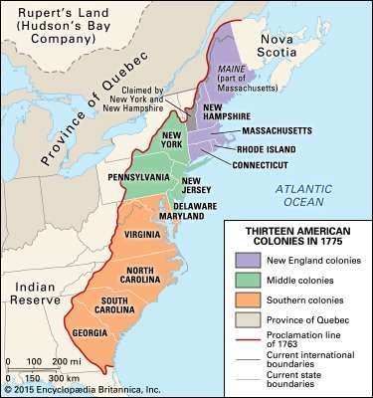
A major reason for this Proclamation of 1763, as it would be called, was to protect Native American lands from colonial expansion and to protect British colonists from Native American violence. However, England also benefitted economically from the proclamation, as all agreements and trade between the colonists and the natives now had to be administered by England. Many colonists simply ignored the Proclamation of 1763 and moved west of the Appalachian Mountains anyway.
Primary Source

“We [England] do, with the Advice of Our Privy Council, strictly enjoin and require, that no private Person do presume to make any Purchase from the said Indians of any Lands reserved to the said Indians.”

“We [England] do, declare and enjoin, that the Trade with the said Indians shall be free and open to all Our Subjects whatever; provided that every Person who may incline to trade with the said Indians, do take out a License for carrying on such Trade from the [royal] Governor [of the colony]”

Document B: Colonial Crowds Protest the Stamp Act, Boston Gazette Newspaper

Background

In 1765 England passed the Stamp Act, which imposed a tax on all printed materials in the American colonies. Taxed items included legal documents, newspapers, and playing cards. Colonists’ protests against the Stamp Act took many forms, including hanging and burning effigies (large doll-like models of people) of British officials, and destroying the offices and houses of Stamp Act commissioners and royal officials. The following account of an attack on Andrew Oliver, Boston’s stamp collector, appeared in the patriot newspaper the Boston Gazette and shows how effective such dramatic crowd actions could be.
Primary Source
Early on Wednesday morning last, the effigy of a gentleman sustaining a very unpopular office, that of Stamp Master, was found hanging on a tree in the most public part of the town – on the breast of the effigy was a label, “in Praise of Liberty” – and underneath was the following words: “HE THAT TAKES THIS DOWN IS AN ENEMY TO HIS COUNTRY.”
… to Oliver’s Dock, where there was a new brick building just finished; and they [the colonists] imagining it to be designed for a “Stamp Office,” instantly set about demolishing of it, which they thoroughly effected in about half an hour. In the meantime the High-Sheriff went and advised them [the Stamp Officer and his family] to evacuate the house… the [mob] went to burn the effigy with the timber and other wood work of the house they had demolished… they set about pulling down a fence upwards of 15 feet high around the [Stamp Officer’s] garden, stripped the trees of their fruit, broke the windows in the rear part of the house, and went down the cellars, and helped themselves to the liquor which they found there…

Name: ____________________________________ Date: _______
US History Weekly #4

Directions: Answer all three questions in complete sentences. Each response should be at least 5 sentences. Your responses must be typed (double-spaced, 12-point font)

Answer Question 1 according to Document A only

- Explain the historical context that led to King George III of England issuing the Proclamation of 1763. Why did he prohibit the colonists from moving west of the Appalachian Mountains?

Answer Questions 2 according to Document B only

- Explain the historical context that led to the riot depicted in the Boston Gazette. (Why did the colonists riot? Why was the Stamp Act passed?)

Answer Question 3 according to both Documents A and B

- Consider cause and effect.
  - How did the colonists react to the Proclamation of 1763? Why?
  - How did the colonists react to the Stamp Act? Why?
  - Why do you think a patriot newspaper would publish the account in Document B? Would the patriots want the public to know about the attack on the tax collector? Why or why not?
(Hint: a patriot was someone who wanted to break away from England)

