Weekly #4 – Due 10/4/19
Document A: The Battle of Saratoga (1777)

The Battle of Saratoga was the turning point of the Revolutionary War.
The scope of the victory is made clear by a few key facts: On October 17, 1777, 5,895 British and Hessian [German mercenaries] troops surrendered their arms. British General John Burgoyne had lost 86 percent of his expeditionary force that had triumphantly marched into New York from Canada in the early summer of 1777.
The divide-and-conquer strategy that Burgoyne presented to British ministers in London was to invade America from Canada by advancing down the Hudson Valley to Albany. There, he would be joined by other British troops under the command of Sir William Howe. Howe would be bringing his troops north from New Jersey and New York City.
Burgoyne believed that this bold stroke would not only isolate New England from the other American colonies, but achieve command of the Hudson River and demoralize Americans
After capturing Fort Ticonderoga in northern New York, Burgoyne continued his march towards Albany, but miles to the south a disturbing event occurred. Sir William Howe decided to attack the Rebel capital at Philadelphia rather than deploying his army to meet up with Burgoyne. Meanwhile, as Burgoyne marched south, his supply lines from Canada were becoming less reliable.
When he finally reached Saratoga, Burgoyne’s British army clashed with the American army there. Burgoyne’s army was defeated handedly by the Americans. The victory gave new life to the American cause at a critical time. Americans had just suffered a major setback the Battle of the Brandywine along with news of the fall of Philadelphia to the British.
One American soldier declared, "It was a glorious sight to see the haughty Britons march out & surrender their arms”
A stupendous American victory in October 1777, the success at Saratoga gave France the confidence in the American cause to enter the war as an American ally. Later American successes owed a great deal to French aid in the form of financial and military assistance.
Interestingly, Benedict Arnold was a hero for the American army at Saratoga. However, he would later become a traitor and join the British after feeling his contributions to the Patriots, specifically at Saratoga, were not being properly recognized.
Document B: The Battle of Yorktown (1781)

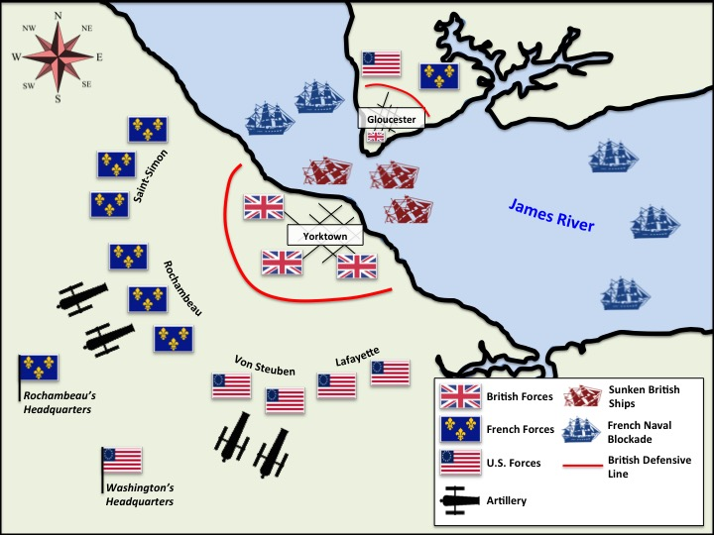

Name: ____________________________________ Date: _______
US History Weekly #4

Directions: Answer all three questions in complete sentences. Each response should be at least 5 sentences. Your responses must be typed (double-spaced, 12-point font)

Answer Questions 1 and 2 according to Document A
- Describe the Battle of Saratoga. What was British General Burgoyne’s plan? Why did it fail? Who won the battle?
- Why was the Battle of Saratoga significant/important? What did it ultimately contribute to the American war effort?

Answer Question 3 according to Documents A and B
- Analyze the map of the Battle of Yorktown, which eventually ended the Revolutionary War. Why was the Battle of Saratoga key in helping the Americans win the Battle of Yorktown? (You will need to THINK in order to respond to this question)

