Weekly #6
Document A: The Louisiana Purchase
The Louisiana Purchase of 1803 brought into the United States about 828 million square miles of territory from France, thereby doubling the size of the young republic. The Louisiana Territory stretched from the Mississippi River in the east to the Rocky Mountains in the west and from the Gulf of Mexico in the south to the Canadian border in the north. Part or all of 15 states were eventually created from the land deal, which is considered one of the most important achievements of Thomas Jefferson’s presidency.
How did the deal happen?
The city of New Orleans, an important port, was located in the Louisiana Territory. France decided to revoke a treaty that the United States had with Spain (who previously owned the territory) that let Americans use the city for trading. President Jefferson tried to negotiate the purchase of New Orleans, but France, amidst their own domestic problems, offered the entire Louisiana Territory for 15 million dollars. At such a good price, Jefferson could not resist, and the United States nearly doubled in size overnight. The famous explorers, Meriwether Lewis and William Clark would be sent to chart the new territory.
The Louisiana Purchase
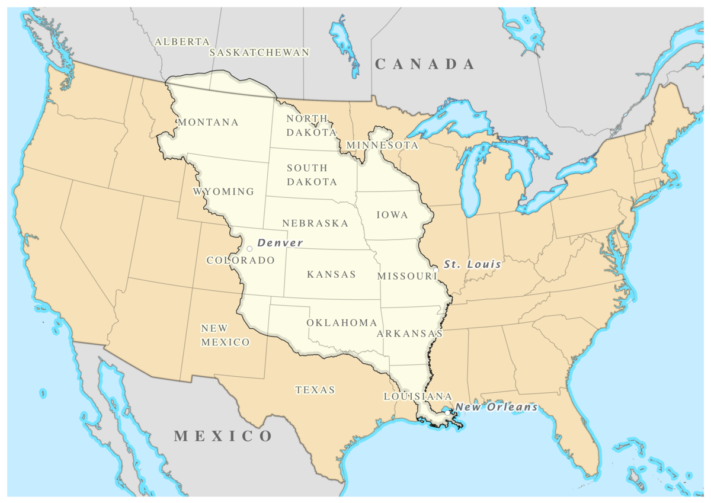
Document B: Manifest Destiny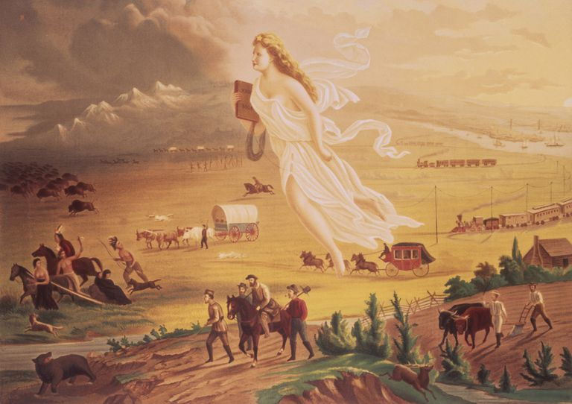
Manifest Destiny refers to the belief that God wanted the United States to own all North America and expand West, all the way to the Pacific coastline. In their quest to conquer the continent, Americans would have to overcome the frontier (unsettled lands), long journeys, and diverse Native American populations. Many Americans believed it was their right and their destiny to own the continent.
Journalist John L O’Sullivan wrote:
“The American claim is by the right of our manifest destiny to overspread and possess the whole of the continent which Providence [God] has given us for the development of the great experiment of liberty and self-government.”

Name: ________________________________________ Date: _______
US History Weekly #6

Directions: Answer all questions in complete sentences. Each response should be at least 5 sentences. Your responses must be typed (double-spaced, 12-point font)

Answer Questions 1 and 2 according to both documents and your knowledge of social studies
- What is expansion?
- What challenges come with trying to expand your nation? What benefits come with expanding your nation?

Answer Question 3 according to Document A
- Describe how the United States acquired the Louisiana Territory. Why did President Jefferson want New Orleans and why do you think acquiring the entire Louisiana Territory would be beneficial?

Answer Question 4 according to Document B
- What is Manifest Destiny? Why do you think the United States would want to expand all the way to the Pacific coastline? Why did Americans use “Manifest Destiny” as a justification to move West?

