Name: _____________________________________________ Date: __________
US History Weekly #8

Directions: Analyze the documents and answer the short answer questions that follow each document.

Document 1a

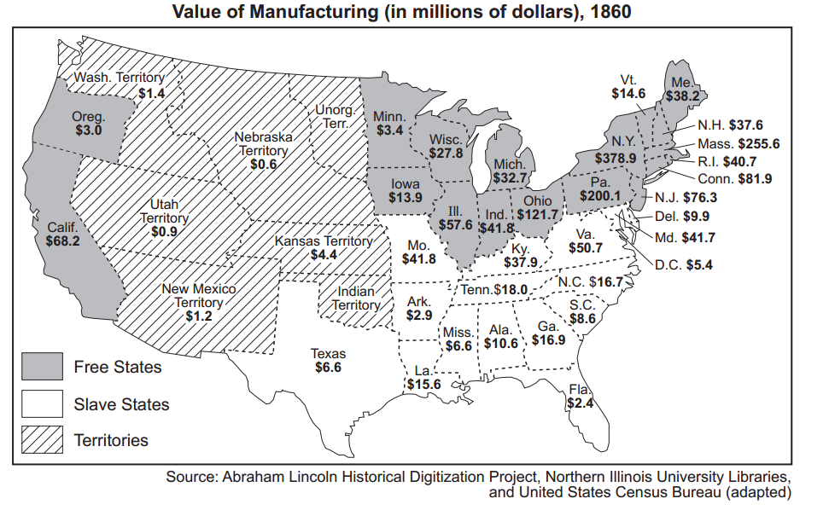

Document 1b Document 1c
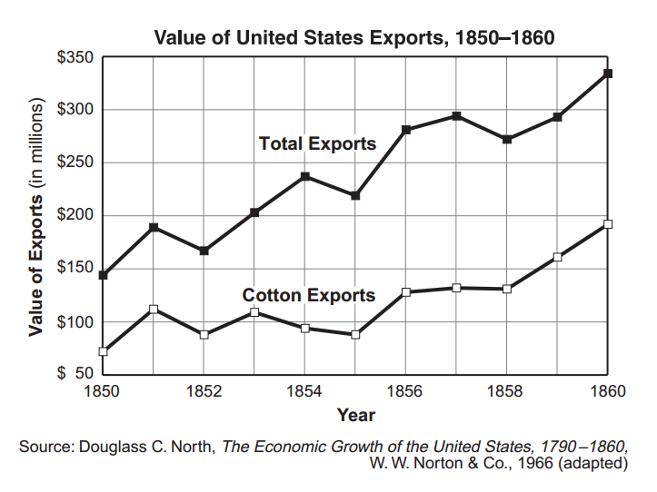
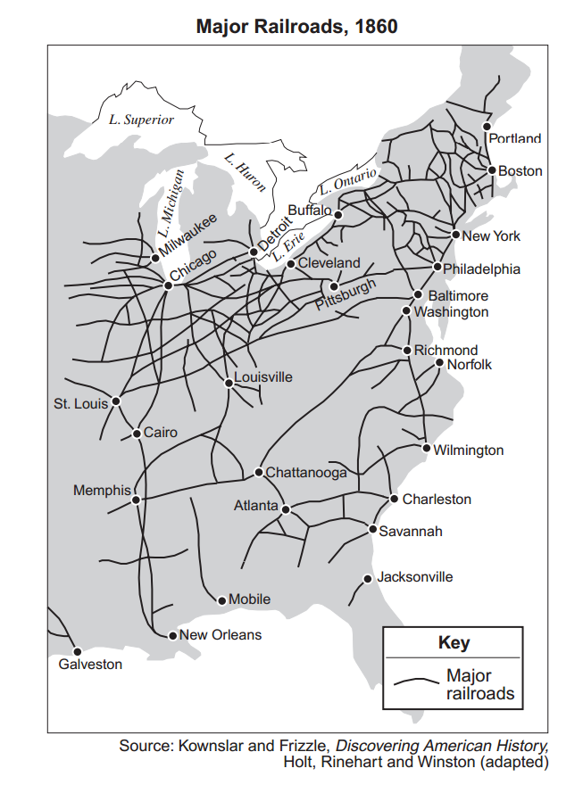

- Based on these three documents, state two differences between the economies of the North and South before the Civil War.

- _________________________________________________________________________________________________________________

_________________________________________________________________________________________________________________

- _________________________________________________________________________________________________________________

_________________________________________________________________________________________________________________

Document 2 - The American Anti-Slavery society was formed in 1833 in Philadelphia. Nearly all of it’s members were from New England states. Agents of the American Anti-Slavery Society traveled throughout the United States to urge the abolition of slavery.

Dear Sir - You have been appointed an Agent of the American Anti-Slavery Society…

...Our object is, the overthrow of American slavery, the most atrocious and oppressive system of bondage that has ever existed in any country. We expect to accomplish this, mainly by showing to the public slavery’s true character and legitimate fruits [real effects] contrariety [opposition] to the first American principles of religion, morals, and humanity, and its special inconsistency with our American democratic aims, as a free, humane, and enlightened people. IN this way, by the force of truth, we expect to correct the common errors that prevail respecting slavery, and to produce a just public sentiment, which shall appeal both to the conscience and love of character, of our slave-holding fellow-citizens, and convince them that both their duty and their welfare require the immediate abolition of slavery… Slavery is un-American.
Source: Letters of Theodore Dwight Weld, Angelina Grimke Weld and Sarah Grimke, 1822 - 1844 American Historical Association 1934

2. Based on this document, what was one argument the American Anti-Slavery society planned to use to promote abolition?

___________________________________________________________________________________________________________________________________________________________________________________________________________________________________________________________________________________________________________________________________________________________________________
Document 3 - Historian Eric Foner was interviewed for a documentary special entitled “Africans in America”. Below is an excerpt of this interview.

Q: What is the relationship between slavery and westward expansion?

A: … The westward expansion carried slavery down into the Southwest, into Mississippi, Alabama, crossing the Mississippi River into Louisiana. Slaveowners insisted that slavery was absolutely essential to progress. Without slavery, you could not have civilization, they said. Slavery freed the upper class from the need to do manual labor and gave them the time to devote themselves to the arts and literature. So that it was slavery itself which made the progress of civilization possible.…Therefore, in order to settle the Southwest and Western territories, slavery would be a necessary institution.
Source: Interview with Eric Foner Africans in America, www.pbs.org/wgbh

3. According to Eric Foner, suggest ONE reason Southern slave owners supported the expansion of slavery into the west.

_________________________________________________________________________________________________________________________

_________________________________________________________________________________________________________________________

Document 4 - Following the Mexican-American War, there was much debate amongst Americans & Congressional leaders regarding whether or not Texas’s petition to join the United States should be ratified. Stephen C Phillips was a congressman from Massachusetts who strongly opposed the annexation of Texas. Below is an excerpt of a speech he gave on this debate.

The plot for the annexation of Texas was taken under the advice, and chiefly through the agency, of slave-holders belonging to the United States, who were intent upon defeating anti-slavery policies of the Mexican republic, and sought at the same time, through the accession of a vast slave-holding territory, to extend and perpetuate the power of the Slave states in this union. Texas should not be annexed, for it would unbalance our nation and our government...
Source: Excerpts from the Address on the Annexation of Texas, and the aspect of Slavery in the United States

4. Why was Stephen Phillips against the annexation of Texas?

_________________________________________________________________________________________________________________________

_________________________________________________________________________________________________________________________

_________________________________________________________________________________________________________________________

Document 5

Selected Proposals for the Compromise of 1850
- That California ought to be admitted into the Union as a free state

- That it is wise to prohibit the slave trade in the District of Columbia

- That stronger provision ought to be made by law for the capture and return of slaves who may have escaped into any other state or territory in the Union [Fugitive Slave Act]
Source: Compromise of 1850

5. Based on this document, what is ONE way in which these proposals favored the free states, mostly located in the North?

_________________________________________________________________________________________________________________________

_________________________________________________________________________________________________________________________

6. Based on this document, what is ONE way in which these proposals favored the slave holding states, mostly located in the South and West?

_________________________________________________________________________________________________________________________

_________________________________________________________________________________________________________________________

Document 6 – Thomas R. Dew defended slavery in a debate in the Virginia Legislature

According to the census of 1830, there were approximately 470,000 slaves in Virginia. The average value of each slave is about $200. Thus, the total value of the slave population in Virginia in 1830 was $94,000,000.

It is, in truth, the slave labor in Virginia which gives value to the soil and to her economy. Take this away and you ruin her. Remove the slave population from the State and it is absolutely safe to say that on the day this happens, Virginia will become a “waste howling wilderness.”

7. According to Thomas R. Dew, what is ONE reason Virginia should not have to give up its slaves?

__________________________________________________________________________________________________________________________________________________________________________________________________________________________________________________
Document 7 - Below is a map of the results of the 1860 election. Using the map and the key, please answer the question below.

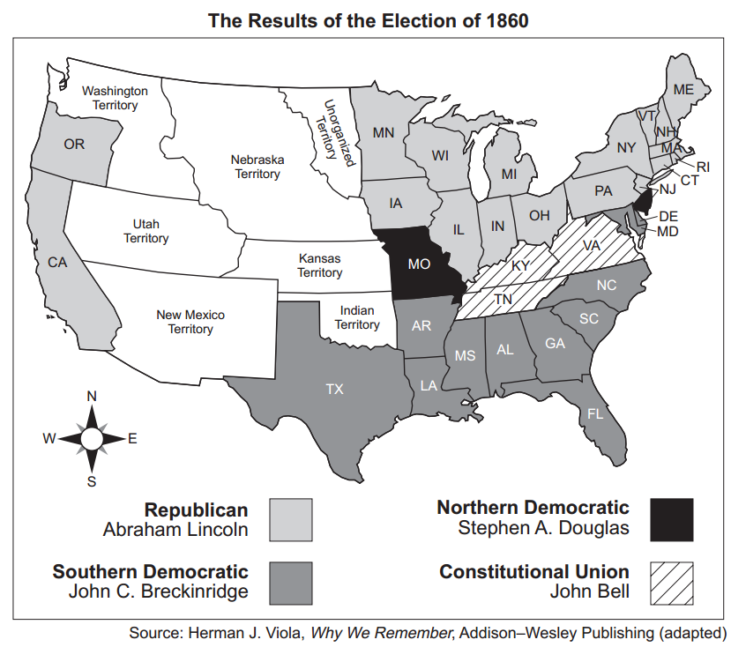

8. Based on this map, how could the election of 1860 & President Abraham Lincoln have contributed to sectional differences between the North and the South prior to the civil war?

___________________________________________________________________________________________________________________________________________________________________________________________________________________________________________________________________________________________________________________________________________________________________________
Document 8 – John B. Gordon was a soldier who fought for the Confederacy during the Civil War. Below, he argues the south was just as justified in seceding from the Union as the original colonies were in breaking away from Great Britain
“… the South believed that the Union formed under the Constitution was a Union of consent and not of force; the original states had gained their independence, their freedom, and their sovereignty from Great Britain. Powers not given to the national government were given to the states; and the south challenged the north to find where in the Constitution they have the power to invade [the Confederacy]”
9. According the John B. Gordon, what was the southern point of view regarding the power of states under the Constitution?

___________________________________________________________________________________________________________________________________________________________________________________________________________________________________________________________________________________________________________________________________________________________________________
10. What did the south ultimately compare their secession to? What earlier historical event did the Confederacy believe it was simply repeating?

___________________________________________________________________________________________________________________________________________________________________________________________________________________________________________________________________________________________________________________________________________________________________________

