Name: _______________________________ Date: _______
US History Gilded Age Working Conditions Primary Source
Factory working conditions: Life in the Shop - Story of an Immigrant Garment Worker
Clara Lemlich ignited the 1909 walkout of shirtwaist makers with her call for a general strike. This piece was first published in the New York Evening Journal, November 28, 1909.

First let me tell you something about the way we work and what we are paid. There are two kinds of work—regular, that is salary work, and piecework. The regular work pays about $6 a week and the girls have to be at their machines at 7 o'clock in the morning and they stay at them until 8 o'clock at night, with just one-half hour for lunch in that time.

The shops. Well, there is just one row of machines that the daylight ever gets to—that is the front row, nearest the window. The girls at all the other rows of machines back in the shops have to work by gaslight, by day as well as by night. Oh, yes, the shops keep the work going at night, too.

The bosses in the shops are hardly what you would call educated men, and the girls to them are part of the machines they are running. They yell at the girls and they "call them down" even worse than I imagine the Negro slaves were in the South.

There are no dressing rooms for the girls in the shops. They have to hang up their hats and coats—such as they are—on hooks along the walls. Sometimes a girl has a new hat. It never is much to look at because it never costs more than 50 cents, that means that we have gone for weeks on two-cent lunches—dry cake and nothing else.

The shops are unsanitary—that's the word that is generally used, but there ought to be a worse one used. Whenever we tear or damage any of the goods we sew on, or whenever it is found damaged after we are through with it, whether we have done it or not, we are charged for the piece and sometimes for a whole yard of the material.

At the beginning of every slow season, $2 is deducted from our salaries. We have never been able to find out what this is for.
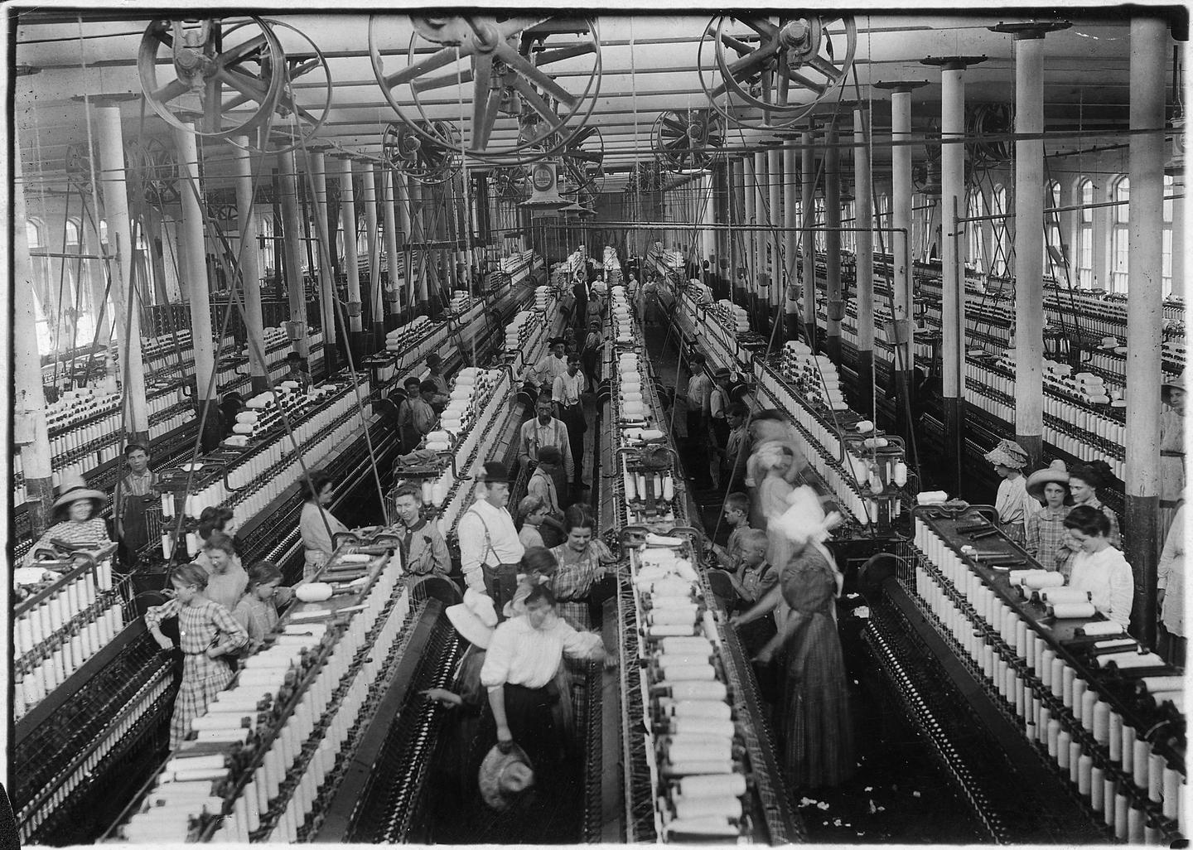
- Describe the working conditions in a factory during the Gilded Age, according to Clara Lemlich
__________________________________________________________________________________________________________________________________________________________________________________________________________________________________________________________________________________________________________________________________________________________________________________________________________________________________________________________________
- Why do you think factories and working conditions were like this at the time?
________________________________________________________________________________________________________________________________________________________________________________________________________________________________________________________________________________________________________________________________________________________________________

