Name: ____________________________ Date: _______
US History & Government World War I Home Front Stations

Station 1: Schenck v. United States

After the United States entered World War I in 1917, the United States immediately needed to expand the size of its military. As a result, America instituted the first ever military draft [system of mandatory army service] of eligible young men with the passage of the Selective Service Act. Not everyone agreed with America’s entry to the global war, nor did everyone agree that drafting men into the US military was the proper course of action. Especially vocal about their opposition to the war was the growing Socialist Party of the United States. The Socialist Party had held many anti-war demonstrations and marches; socialists believed that the war would benefit only the rich, while causing suffering and death for the thousands of poor and working-class soldiers who would do the actual fighting in Europe.
In order to protect the war effort, Congress also passed the Espionage Act of 1917 and the Sedition Bills of 1918. Among other things, these laws made it a crime to cause or attempt to cause insubordination [refusing to obey orders] in the military and naval forces or to obstruct [prevent] the recruitment or enlistment of persons into the military service of the United States.
In 1919, 15,000 leaflets urging resistance to the draft were sent to men who had been drafted by the US Army. On the front of the leaflet the first section of the Thirteenth Amendment to the U.S. Constitution, which prohibits slavery or involuntary servitude, was printed. The leaflet asserted that the Selective Service Act violated the idea embodied in the 13th amendment and that a draftee was little better than a convict. In passionate language, it suggested that conscription [being drafted into the military] was despotism [exercise of absolute power in a cruel manner] in its worst form and a monstrous wrong against humanity in the interest of “Wall Street’s chosen few” who would profit from the war.
The leaflets were traced to Socialist Party headquarters, specifically to Charles Schenck, the General Secretary of the Socialist Party, who publicly and vocally had opposed United States participation in World War I. Charles Schenck was arrested for violating the Espionage & Sedition Acts. Although Schenck denied responsibility for sending the leaflets, he was arrested, and, among other charges, was indicted for “conspiring to violate the Espionage Act … by causing and attempting to cause insubordination … and to obstruct the recruiting and enlistment service of the United States.” He was found guilty in a US district court and as such appealed his conviction to the United States Supreme Court - and claiming that the leaflets should be protected as free speech.

Station 2: African Americans and the Great Migration
Source: Excerpt from W.E.B. DuBois’s article, “The Migration of the Negroes” (June 1917) from Crisis Magazine

… As to the reasons of the migration, undoubtedly, the first & immediate cause was economic, the movement began because of floods in middle Alabama and Mississippi and because the latest devastation of the boll weevil [beetle that feeds on cotton plants - ruins cotton harvest] came in these same districts. A second economic cause was the cutting off of immigration from Europe to the North and the consequently widespread demand for common labor… The third reason has been outbreaks of mob violence in northern and southwestern Georgia and in western South Carolina...

These have been the… immediate causes, but back of them is, undoubtedly, the general dissatisfaction with the conditions in the South. Individuals have given us the following reasons for migration from certain points:
- Birmingham, Ala., right to vote, discontent, bad treatment, low wages, lynching
- Montgomery, Ala., low wages, lack of employment, bad treatment, oppression
- South Atlanta, Ga., schools, freedom, civil rights, low wages, lynching
- Covington, Ga., low wages, lynching
- Augusta, Ga., low wages, bad treatment
- Nashville, Tenn., low wages, violence and lynching
- Jackson, Miss., low wages, discrimination
…we face here a social change among American Negroes of great moment, and one which needs to be watched with intelligent interest.
One Way Ticket by Langston Hughes

I pick up my life, And take it with me,
And I put it down in
Chicago, Detroit, Buffalo, Scranton,
Any place that is North and East, And not Dixie.

I pick up my life And take it on the train,
To Los Angeles, Bakersfield, Seattle, Oakland, Salt Lake
Any place that is North and West, And not South.

I am fed up With Jim Crow laws,
People who are cruel And afraid,
Who lynch and run,
Who are scared of me And me of them
I pick up my life And take it away
On a one-way ticket-
Gone up North Gone out West
Gone

Migration Patterns of African Americans
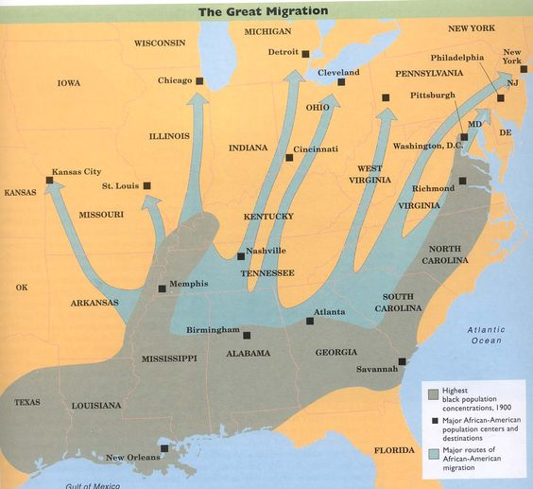

Stations 3: The Role of Women in World War I

After the United States entered the war in 1917, women supported the war effort in numerous ways. Women at home sold war bonds and actively conserved food supply to be able to share with the troops abroad; some went so far as to plant victory gardens at home. Victory gardens provided American families and their neighbors with self-supplied food so other food could be sent to the troops overseas. Women sent relief supplies to suffering Europeans. Some women’s groups sent delegations to Europe to provide relief for American soldiers.

During the war, women also entered the workforce in new ways. Women served in the navy and marines, and thousands served as nurses. On the home front, women worked in factories and in the government. This era marked the first time in history that a majority of American women between the ages of 18 - 40 left the household to seek employment.

World War I led to several important advances for women. Women’s war work increased support for woman suffrage and contributed to the passage of the 19th Amendment in 1920.

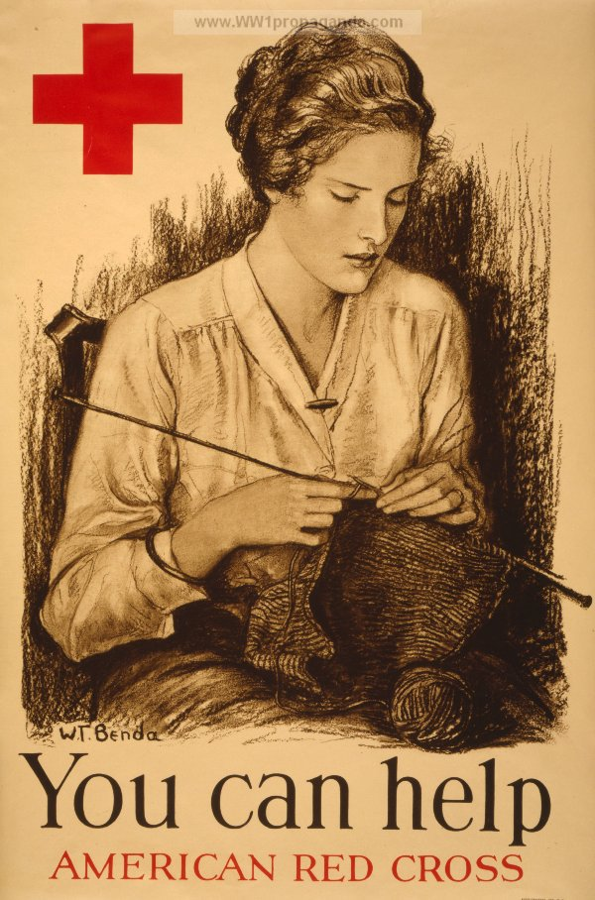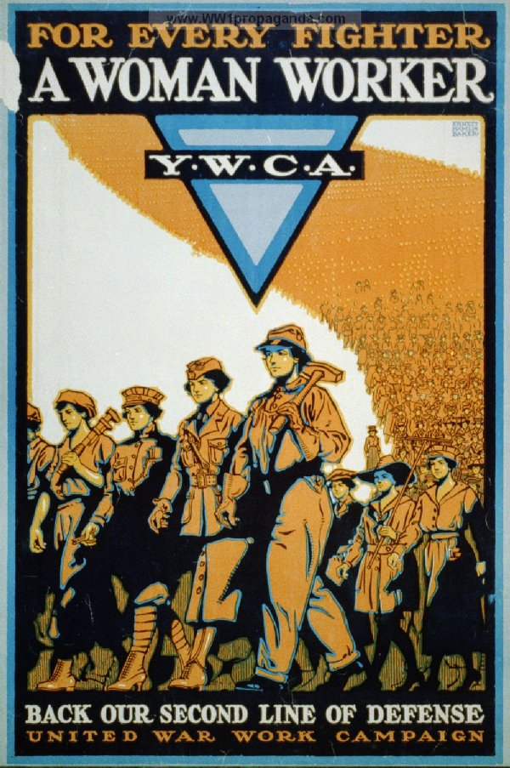

Station 4: Propaganda

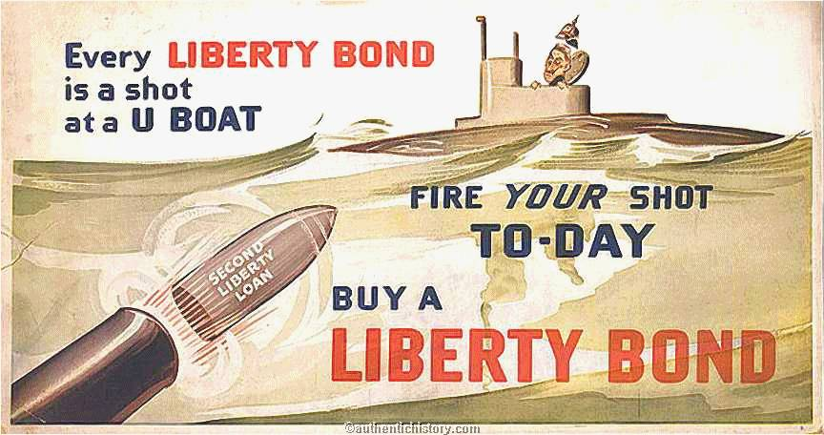

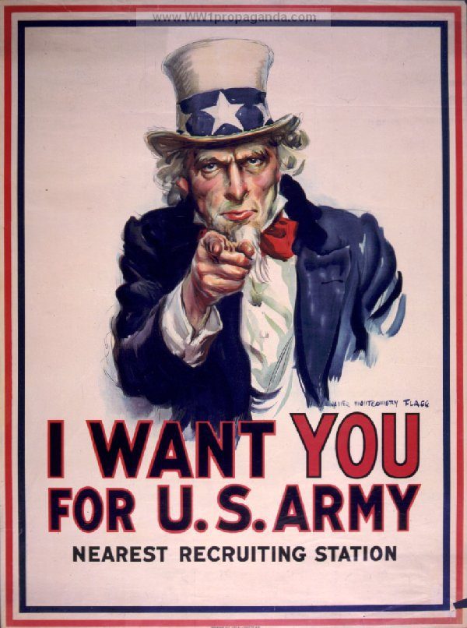
The U.S. government took loans from American citizens in the form of “Liberty Bonds.” Bonds were a way for the government to quickly raise money for the war effort.

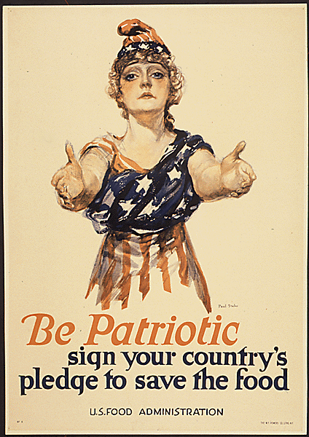

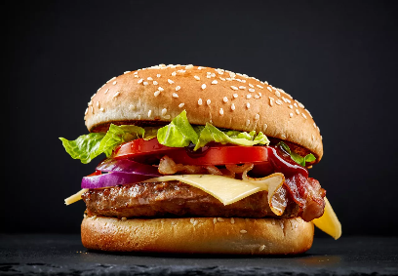
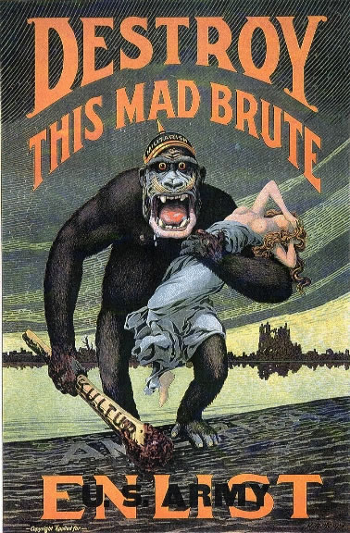
The U.S. showed prejudice against German culture during the war. German was no longer taught in schools and German-Americans had to pledge loyalty to the United States. Hamburgers, which were invented in Hamburg, Germany, were called “Liberty Steaks.”

